support@mytectra.com

Call Us: +91-90191-91856

Top of Form



Bottom of Form

[Login / Register](https://www.mytectra.com/interview-question/121-manual-testing-interview-questions-and-answers/#w-login)

[](https://www.mytectra.com/interview-question/)

* [POPULAR COURSES](https://www.mytectra.com/popular-it-courses)
* [IT COURSES](https://www.mytectra.com/it-courses)
* [BUSINESS COURSES](https://www.mytectra.com/business-courses)
* [CORPORATE TRAINING](https://www.mytectra.com/corporate-training)
* [DIGITAL](https://www.mytectra.com/digital-marketing)

Top of Form





Bottom of Form

* [**POPULAR COURSES**](https://www.mytectra.com/popular-it-courses)
* [**IT COURSES**](https://www.mytectra.com/it-courses)
* [**BUSINESS COURSES**](https://www.mytectra.com/business-courses)
* [**CORPORATE TRAINING**](https://www.mytectra.com/corporate-training)
* [**DIGITAL**](https://www.mytectra.com/digital-marketing)

[**PREVIOUS ARTICLE**Oracle PL SQL Interview Questions and Answers](https://www.mytectra.com/interview-question/top-oracle-pl-sql-interview-questions-and-answers-2017/)

[**NEXT ARTICLE**Oracle OBIEE Interview Questions and Answers](https://www.mytectra.com/interview-question/top-oracle-obiee-interview-questions-2017/)

**121 Manual Testing Interview Questions and Answers**

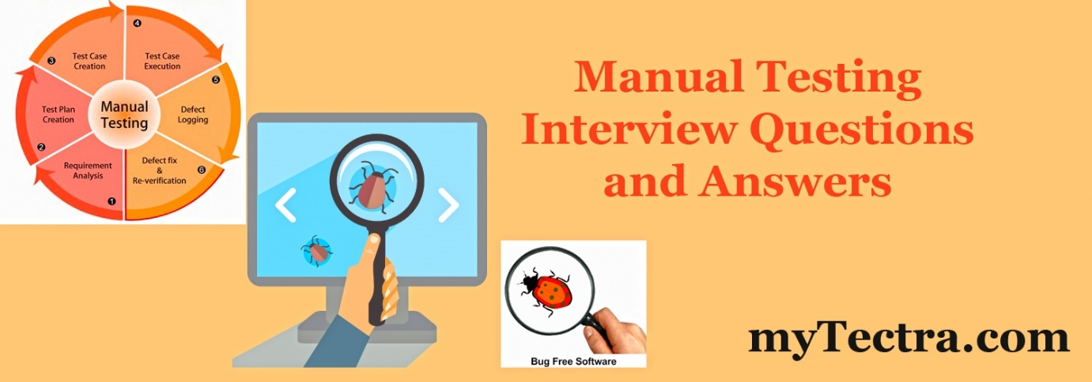



**BY** [SONIA](https://www.mytectra.com/interview-question/profile/developer2/)

May 24, 2017

in[**INFORMATION TECHNOLOGIES (IT)**](https://www.mytectra.com/interview-question/category/it/)

No Comments

6186

**Q1). What is the difference between Functional Requirement and Non-Functional Requirement?**  
**Ans:** The Functional Requirement specifies how the system or application SHOULD DO where in  
Non Functional Requirement it specifies how the system or application SHOULD BE.  
**Some functional Requirements are**

* Authentication
* Business rules
* Historical Data
* Legal and Regulatory Requirements
* External Interfaces

**Some Non-Functional Requirements are**

* Performance
* Reliability
* Security
* Recovery
* Data Integrity
* Usability

**Q2). How Severity and Priority are related to each other?**  
**Ans:**

* Severity- tells the seriousness/depth of the bug where as
* Priority- tells which bug should rectify first.
* Severity- Application point of view
* Priority- User point of view

**Q3). Explain the different types of Severity?**  
**Ans:**

1. User Interface Defect-**Low**
2. Boundary Related Defects-**Medium**
3. Error Handling Defects-**Medium**
4. Calculation Defects-**High**
5. Interpreting Data Defects-**High**
6. Hardware Failures& Problems-**High**
7. Compatibility and Inter system defects-**High**
8. Control Flow defects-**High**
9. Load conditions (Memory leakages under load testing)-**High**

**Q4a). What is the difference between Priority and Severity?  
Ans:** The terms Priority and Severity are used in Bug Tracking to share the importance of a bug among the team and to fix it.  
Severity: Is found in the Application point of view  
**Priority**– Is found in the User point of view  
**Severity**– (tells the seriousness/depth of the bug)

1. The Severity status is used to explain how badly the deviation is affecting the build.
2. The severity type is defined by the tester based on the written test cases and functionality.

**Example**  
If an application or a web page crashes when a remote link is clicked, in this case clicking the remote link by an user is rare but the impact of application crashing is severe, so the severity is high and priority is low.  
**PRIORITY-** (tells which bug should rectify first)

1. The Priority status is set by the tester to the developer mentioning the time frame to fix a defect. If High priority is mentioned then the developer has to fix it at the earliest.
2. The priority status is set based on the customer requirements.

**Example**  
If the company name is misspelled in the home page of a website, then the priority is high and the severity is low to fix it.  
**Severity**: Describes the bug in terms of functionality.  
**Priority**: Describes the bug in terms of customer.  
**Few examples:**  
**High Severity and Low Priority ->** Application doesn’t allow customer expected configuration.  
**High Severity and High Priority ->** Application doesn’t allow multiple user’s.  
**Low Severity and High Priority ->** No error message to prevent wrong operation.  
**Low Severity and low Priority ->** Error message is having complex meaning.  
**Or**  
**Few examples:**  
**High Severity -Low priority**  
Supposing, you try the wildest or the weirdest of operations in a software (say, to be released the next day) which a normal user would not do and supposing this renders a run -time error in the application,the severity would be high. The priority would be low as the operations or the steps which rendered this error by most chances will not be done by a user.  
**Low Severity -High priority**  
An example would be- you find a spelling mistake in the name of the website which you are testing.Say, the name is supposed to be Google and its spelled there as ‘Gaogle’. Though, it doesn’t affect the basic functionality of the software, it needs to be corrected before the release. Hence, the priority is high.  
**High severity- High Priority**  
A bug which is a show stopper. i.e., a bug due to which we are unable to proceed our testing.An example would be a run time error during the normal operation of the software,which would cause the application to quit abruptly.  
**Low severity – low priority**  
Cosmetic bugs

**Q4b). What is Defect Severity?**  
**Ans:** A defect is a product anomaly or flaw, which is variance from desired product specification. The classification of defect based on its impact on operation of product is called Defect Severity.

**Q5). What is Bucket Testing?**  
**Ans:** Bucket testing (also known as A/B Testing) is mostly used to study the impact of various product designs in website metrics, two simultaneous versions were run in a single or set of web pages to measure the difference in click rates, interface and traffic.

[](https://www.mytectra.com/manual-testing-training.html)

**Q6). What is Entry and Exit Criteria in Software Testing?**  
**Ans:** Entry Criteria is the process that must be present when a system begins, like,

* SRS (Software Requirement Specification)
* FRS (Functional Requirement Specification)
* Usecase
* Test Case
* Test plan

Exit Criteria ensures whether testing is completed and the application is ready for release, like,

* Test Summary Report
* Metrics
* Defect Analysis report

**Q7). What is Concurrency Testing?**  
**Ans:** Concurrency Testing (also commonly known as Multi User Testing) is used to know the effects of accessing the Application, Code Module or Database by different users at the same time.It helps in identifying and measuring the problems in Response time, levels of locking and deadlocking in the application.  
**Example**  
Load runner is widely used for this type of testing, Vugen (Virtual User Generator) is used to add the number of concurrent users and how the users need to be added like Gradual Ramp up or Spike Stepped.

**Q8). Explain Statement coverage/Code coverage/Line Coverage?**  
**Ans:** Statement Coverage or Code Coverage or Line Coverage is a metric used in White Box Testing where we can identify the statements executed and where the code is not executed cause of blockage. In this process each and every line of the code needs to be checked and executed.

**Some advantages of Statement Coverage / Code Coverage / Line Coverage are**

* It verifies what the written code is expected to do and not to do.
* It measures the quality of code written.
* It checks the flow of different paths in the program also ensure whether those paths are tested or not.

**To Calculate Statement Coverage,**  
Statement Coverage = Statements Tested / Total No. of Statements.

**Q9). Explain Branch Coverage/Decision Coverage?**  
**Ans:** Branch Coverage or Decision Coverage metric is used to check the volume of testing done in all components. This process is used to ensure whether all the code is executed by verifying every branch or decision outcome (if and while statements) by executing atleast one time, so that no branches lead to the failure of the application.  
To Calculate Branch Coverage,  
Branch Coverage = Tested Decision Outcomes / Total Decision Outcomes.

**Q10). What is the difference between High level and Low Level test case?**  
**Ans:** **High level** Test cases are those which cover major functionality in the application (i.e. retrieve, update display, cancel (functionality related test cases), database test cases).  
**Low level** test cases are those related to User Interface (UI) in the application.

[](https://www.mytectra.com/hadoop-administration-training.html)

**Q11). Explain Localization testing with example?**  
**Ans:** **Localization** is the process of changing or modifying an application to a particular culture or locale. This includes change in user interface, graphical designs or even the initial settings according to their culture and requirements.  
In terms of Localization Testing it verifies how correctly the application is changed or modified into that target culture and language.  
In case of translation required of the application on that local language, testing should be done on each field to check the correct translation. Other formats like date conversion, hardware and software usage like operating system should also be considered in localization testing.  
**Examples for Localization Testing are**  
In Islamic Banking all the transactions and product features are based on Shariah Law, some important points to be noted in Islamic Banking are

1. In Islamic Banking, the bank shares the profit and loss with the customer.
2. In Islamic Banking, the bank cannot charge interest on the customer; instead they charge a nominal fee which is termed as “Profit
3. In Islamic Banking, the bank will not deal or invest in business like Gambling, Alcohol, Pork, etc.

In this case, we need to test whether these Islamic banking conditions were modified and applied in the application or product.  
In Islamic Lending, they follow both the Gregorian calendar and Hijiri Calendar for calculating the loan repayment schedule. The Hijiri Calendar is commonly called as Islamic Calendar followed in all the Muslim countries according to the lunar cycle. The Hijiri Calendar has 12 months and 354 days which is 11 days shorter than Gregorian calendar. In this case, we need to test the repayment schedule by comparing both the Gregorian calendar and Hijiri Calendar.

**Q12). Explain Risk Analysis in Software Testing?**  
**Ans:** In Software Testing, Risk Analysis is the process of identifying risks in applications and prioritizing them to test.

**In Software testing some unavoidable risk might takes place like**

* Change in requirements or Incomplete requirements
* Time allocation for testing.
* Developers delaying to deliver the build for testing.
* Urgency from client for delivery.
* Defect Leakage due to application size or complexity.

**To overcome these risks, the following activities can be done**

* Conducting Risk Assessment review meeting with the development team.
* Profile for Risk coverage is created by mentioning the importance of each area.
* Using maximum resources to work on High Risk areas like allocating more testers for High risk areas and minimum resources for Medium and Low risk areas. Creation of Risk assessment database for future maintenance and management review.

**Q13). What is the difference between Two Tier Architecture and Three Tier Architecture?  
Ans:**  
**In Two Tier Architecture or Client/Server Architecture** two layers like Client and Server is involved. The Client sends request to Server and the Server responds to the request by fetching the data from it. The problem with the Two Tier Architecture is the server cannot respond to multiple requests at the same time which causes data integrity issues.  
The Client/Server Testing involves testing the Two Tier Architecture of user interface in the front end and database as backend with dependencies on Client, Hardware and Servers.  
**In Three Tier Architecture or Multi Tier Architecture** three layers like Client, Server and Database are involved. In this the Client sends a request to Server, where the Server sends the request to Database for data, based on that request the Database sends back the data to Server and from Server the data is forwarded to Client.  
The Web Application Testing involves testing the Three Tier Architecture including the User interface, Functionality, Performance, Compatibility, Security and Database testing.

**Q14). What is the difference between Static testing and dynamic testing?**  
**Ans:** **Static Testing** **(done in Verification stage)**  
Static Testing is a White Box testing technique where the developers verify or test their code with the help of checklist to find errors in it, this type of testing is done without running the actually developed application or program. Code Reviews, Inspections, Walkthroughs are mostly done in this stage of testing.  
**Dynamic Testing** **(done in Validation stage)**  
Dynamic Testing is done by executing the actual application with valid inputs to check the expected output. Examples of Dynamic Testing methodologies are Unit Testing, Integration Testing, System Testing and Acceptance Testing.  
Some differences between Static Testing and Dynamic Testing are,

* Static Testing is more cost effective than Dynamic Testing because Static Testing is done in the initial stage.
* In terms of Statement Coverage, the Static Testing covers more areas than Dynamic Testing in shorter time.
* Static Testing is done before the code deployment where the Dynamic Testing is done after the code deployment.
* Static Testing is done in the Verification stage where the Dynamic Testing is done in the Validation stage.

**Q15). Explain Use case diagram. What are the attributes of use cases?**  
**Ans:** Use Case Diagrams is an overview graphical representation of the functionality in a system. It is used in the analysis phase of a project to specify the system to be developed.  
In Use Case Diagrams the whole system is defined as ACTORS, USE CASES and ASSOCIATIONS, the ACTORS are the external part of the system like users, computer software & hardware, USECASES is the behavior or functionality of the system when these ACTORS perform an action, the ASSOCIATIONS are the line drawn to show the connection between ACTORS and USECASES. One ACTOR can link too many USECASES and one USECASE can link too many ACTORS.

[](https://www.mytectra.com/python-training-in-bangalore.html)

**Q16). What is Web Application testing? Explain the different phases in Web Ans:** **Ans:** **Application testing?**  
Web Application testing is done on a website to check its load, performance, Security, Functionality, Interface, compatibility and other usability related issues. In Web application testing, three phases of testing is done, they are,  
**Web Tier Testing**  
In Web tier testing, the browser compatibility of the application will be tested for IE, Fire Fox and other web browsers.  
**Middle Tier Testing**  
In Middle tier testing, the functionality and security issues were tested.  
**Database Tier Testing**  
In Database tier testing, the database integrity and the contents of the database were tested and verified.

**Q17). Explain Unit testing, Interface Testing and Integration testing. Also explain the types of integration testing in brief?**  
**Unit testing**  
**Ans:** Unit Testing is done to check whether the individual modules of the source code are working properly. i.e. testing each and every unit of the application separately by the developer in developer’s environment.  
**Interface Testing**  
Interface Testing is done to check whether the individual modules are communicating properly one among other as per the specifications.  
Interface testing is mostly used in testing the user interface of GUI application.  
**Integration testing**  
Integration Testing is done to check the connectivity by combining all the individual modules together and test the functionality.  
**The types of Integration Testing are**

1. **Big Bang Integration Testing**

In Big Bang Integration Testing, the individual modules are not integrated until all the modules are ready. Then they will run to check whether it is performing well.  
In this type of testing, some disadvantages might occur like,  
Defects can be found at the later stage.It would be difficult to find out whether the defect arouse in Interface or in module.

1. **Top Down Integration Testing**

In Top Down Integration Testing, the high level modules are integrated and tested first. i.e Testing from main module to sub module. In this type of testing, Stubs are used as temporary module if a module is not ready for integration testing.  
**3.  Bottom Up Integration Testing**  
In Bottom Up Integration Testing, the low level modules are integrated and tested first i.e Testing from sub module to main module. Same like Stubs, here drivers are used as a temporary module for integration testing.

**Q18). Explain Alpha, Beta, Gamma Testing?**  
**Ans:** **Alpha Testing:**  
Alpha Testing is mostly like performing usability testing which is done by the in-house developers who developed the software or testers. Sometimes this Alpha Testing is done by the client or an outsider with the presence of developer and tester. The version release after alpha testing is called Alpha Release.  
**Beta Testing:**  
Beta Testing is done by limited number of end users before delivery, the change request would be fixed if the user gives feedback or reports defect. The version release after beta testing is called beta Release.  
**Gamma Testing:**  
Gamma Testing is done when the software is ready for release with specified requirements, this testing is done directly by skipping all the in-house testing activities.

**Q19). Explain the methods and techniques used for Security Testing?**  
**Ans:** Security testing can be performed in many ways like,

1. Black Box Testing
2. White Box Testing
3. Database Testing
4. **Black Box Testing**
5. **Session Hijacking**

Session Hijacking commonly called as “IP Spoofing” where a user session will be attacked on a protected network.

1. **Session Prediction**

Session prediction is a method of obtaining data or a session ID of an authorized user and gets access to the application. In a web application the session ID can be retrieved from cookies or URL.  
The session prediction happening can be predicted when a website is not responding normally or stops responding for an unknown reason.  
**c. Email Spoofing**  
Email Spoofing is duplicating the email header (“From” address) to look like originated from actual source and if the email is replied it will land in the spammers inbox. By inserting commands in the header the message information can be altered. It is possible to send a spoofed email with information you didn’t write.

1. **Content Spoofing**

Content spoofing is a technique to develop a fake website and make the user believe that the information and website is genuine. When the user enters his Credit Card Number, Password, SSN and other important details the hacker can get the data and use if for fraud purposes.  
**e. Phishing**  
Phishing is similar to Email Spoofing where the hacker sends a genuine look like mail attempting to get the personal and financial information of the user. The emails will appear to have come from well known websites.  
**f. Password Cracking**  
Password Cracking is used to identify an unknown password or to identify a forgotten password  
Password cracking can be done through two ways,

1. **Brute Force â€“**The hacker tries with a combination of characters within a length and tries until it is getting accepted.
2. **Password Dictionary**â€“ The hacker uses the Password dictionary where it is available on various topics.
3. **White Box level**
4. **Malicious Code Injection**

SQL Injection is most popular in Code Injection Attack, the hacker attach the malicious code into the good code by inserting the field in the application. The motive behind the injection is to steal the secured information which was intended to be used by a set of users.  
Apart from SQL Injection, the other types of malicious code injection are XPath Injection, LDAP Injection, and Command Execution Injection. Similar to SQL Injection the XPath Injection deals with XML document.  
**b. Penetration Testing:**  
Penetration Testing is used to check the security of a computer or a network. The test process explores all the security aspects of the system and tries to penetrate the system.  
**c. Input validation:**  
Input validation is used to defend the applications from hackers. If the input is not validated mostly in web applications it could lead to system crashes, database manipulation and corruption.  
**d. Variable Manipulation**  
Variable manipulation is used as a method for specifying or editing the variables in a program. It is mostly used to alter the data sent to web server.  
**3. Database Level**

1. **SQL Injection**

SQL Injection is used to hack the websites by changing the backend SQL statements, using this technique the hacker can steal the data from database and also delete and modify it.

**Q20). Explain IEEE 829 standards and other Software Testing standards?**  
**Ans:** An IEEE 829 standard is used for Software Test Documentation, where it specifies format for the set of documents to be used in the different stages software testing. The documents are,  
**Test Plan-**Test Plan is a planning document which has information about the scope, resources, duration, test coverage and other details.  
**Test Design**– Test Design document has information of test pass criteria with test conditions and expected results.  
**Test Case-** Test case document has information about the test data to be used.  
**Test Procedure-** Test Procedure has information about the test steps to be followed and how to execute it.  
**Test Log-** Test log has details about the run test cases, test plans & fail status, order, and the resource information who tested it.  
**Test Incident Report-** Test Incident Report has information about the failed test comparing the actual result with expected result.  
**Test Summary Report-** Test Summary Report has information about the testing done and quality of the software, it also analyses whether the software has met the requirements given by customer.  
The other standards related to software testing are,  
IEEE 1008 is for Unit Testing  
IEEE 1012 is for Software verification and validation  
IEEE 1028 is for Software Inspections  
IEEE 1061 is for Software metrics and methodology  
IEEE 1233 is for guiding the SRS development  
IEEE 12207 is for SLC process

[](https://www.iteanz.com/)

**Q21). What is Test Harness?**  
**Ans:** Test Harness is configuring a set of tools and test data to test an application in various conditions, which involves monitoring the output with expected output for correctness.  
The benefits of Test Harness are,

* Productivity increase due to process automation.
* Quality in the application.

**Q22). What is the difference between bug log and defect tracking?**  
**Ans:** **Bug Log:** Bug Log document showing the number of defect such as open, closed, reopen or deferred of a particular module  
**Defect Tracking-** The process of tracking a defect such as symptom, whether reproducible /not, priority, severity and status.

**Q23). What are Integration Testing and Regression Testing?  
Ans:**  
**Integration Testing:**

* Combining the modules together & construct software architecture.
* To test the communication & data flow
* White & Black box testing techniques are used
* It is done by developer & tester

**Regression Testing**

* It is re-execution of our testing after the bug is fixed to ensure that the build is free from bugs.
* Done after bug is fixed
* It is done by Tester

**Q24). Explain Peer Review in Software Testing?  
Ans:**  
It is an alternative form of Testing, where some colleagues were invited to examine your work products for defects and improvement opportunities.  
Some Peer review approaches are,  
**Inspection**  
It is a more systematic and rigorous type of peer review. Inspections are more effective at finding defects than are informal reviews.  
Ex: In Motorola’s Iridium project nearly 80% of the defects were detected through inspections where only 60% of the defects were detected through formal reviews.  
**Team Reviews:** It is a planned and structured approach but less formal and less rigorous comparing to Inspections.  
Walkthrough: It is an informal review because the work product’s author describes it to some colleagues and asks for suggestions. Walkthroughs are informal because they typically do not follow a defined procedure, do not specify exit criteria, require no management reporting, and generate no metrics.

Or

**A ‘walkthrough’** is an informal meeting for evaluation or informational purposes. Little or no preparation is usually required.  
**Pair Programming:** In Pair Programming, two developers work together on the same program at a single workstation and continuously reviewing their work.  
**Peer Desk check**  
In Peer Desk check only one person besides the author examines the work product. It is an informal review, where the reviewer can use defect checklists and some analysis methods to increase the effectiveness.  
**Passaround:** It is a multiple, concurrent peer desk check where several people are invited to provide comments on the product.

**Q25). Explain Compatibility testing with an example?  
Ans:**  
Compatibility testing is to evaluate the application compatibility with the computing environment like Operating System, Database, Browser compatibility, backwards compatibility, computing capacity of the Hardware Platform and compatibility of the Peripherals.  
**Example**  
If Compatibility testing is done on a Game application, before installing a game on a computer, its compatibility is checked with the computer specification that whether it is compatible with the computer having that much of specification or not.

**Q26). What is Traceability Matrix?  
Ans:**  
Traceability Matrix is a document used for tracking the requirement, Test cases and the defect. This document is prepared to make the clients satisfy that the coverage done is complete as end to end, this document consists of Requirement/Base line doc Ref No., Test case/Condition, Defects / Bug id. Using this document the person can track the Requirement based on the Defect id.

**Q27). Explain Boundary value testing and Equivalence testing with some examples?  
Ans:**  
Boundary value testing is a technique to find whether the application is accepting the expected range of values and rejecting the values which falls out of range.  
**Exmple**  
A user ID text box has to accept alphabet characters ( a-z ) with length of 4 to 10 characters.  
BVA is done like this, max value: 10 pass; max-1: 9 pass;  
max+1=11 fail ;min=4 pass;min+1=5 pass;min-1=3 fail;  
Like wise we check the corner values and come out with a conclusion whether the application is accepting correct range of values.  
**Equivalence testing** is normally used to check the type of the object.  
**Example**  
A user ID text box has to accept alphabet characters (a – z) with length of 4 to 10 characters.  
In +ve condition we have test the object by giving alphabets. i.e. a-z char only, after that we need to check whether the object accepts the value, it will pass.  
In -ve condition we have to test by giving other than alphabets (a-z) i.e. A-Z, 0-9, blank etc, it will fail.

**Q28). What is Security testing?  
Ans:**  
Security testing is the process that determines that confidential data stays confidential  
Or  
Testing how well the system protects against unauthorized internal or external access, willful damage, etc?  
This process involves functional testing, penetration testing and verification.

**Q29). What is Installation testing?  
Ans:**  
Installation testing is done to verify whether the hardware and software are installed and configured properly. This will ensure that all the system components were used during the testing process. This Installation testing will look out the testing for a high volume data, error messages as well as security testing.

**Q30). What is AUT?  
Ans:**  
AUT is nothing but “Application Under Test”. After the designing and coding phase in Software development life cycle, the application comes for testing then at that time the application is stated as Application Under Test.

**Q31). What is Defect Leakage?  
Ans:**  
Defect leakage occurs at the Customer or the End user side after the application delivery. After the release of the application to the client, if the end user gets any type of defects by using that application then it is called as Defect leakage. This Defect Leakage is also called as Bug Leakage.

**Q32). What are the contents in an effective Bug report?**  
**Ans:**

1. Project
2. Subject
3. Description
4. Summary
5. Detected By (Name of the Tester)
6. Assigned To (Name of the Developer who is supposed to the Bug)
7. Test Lead (Name)
8. Detected in Version
9. Closed in Version
10. Date Detected
11. Expected Date of Closure
12. Actual Date of Closure
13. Priority (Medium, Low, High, Urgent)
14. Severity (Ranges from 1 to 5)
15. Status
16. Bug ID
17. Attachment
18. Test Case Failed (Test case that is failed for the Bug)

**Q33). What is Error guessing and Error seeding?**  
**Ans:** Error Guessing is a test case design technique where the tester has to guess what faults might occur and to design the tests to represent them.  
Error Seeding is the process of adding known faults intentionally in a program for the reason of monitoring the rate of detection & removal and also to estimate the number of faults remaining in the program.

**Q34). What is Ad-hoc testing?**  
**Ans:** Ad hoc testing is concern with the Application Testing without following any rules or test cases.  
For Ad hoc testing one should have strong knowledge about the Application.

**Q35). What are the basic solutions for the software development problems?**  
**Ans:**

1. **Basic requirements-** A clear, detailed, complete, achievable, testable requirement has to be developed. Use some prototypes to help pin down requirements. In nimble environments, continuous and close coordination with customers/end-users is needed.
2. **Schedules should be realistic-**enough time to plan, design, test, bug fix, re-test, change, and document in the given schedule. Adequate
3. **testing**– testing should be started early, it should be re-tested after the bug fixed or changed, enough time should be spend for testing and bug-fixing.
4. **Proper study on initial requirements-**be ready to look after more changes after the development has begun and be ready to explain the changes done to others. Work closely with the customers and end-users to manage expectations. This avoids excessive changes in the later stages.
5. **Communication-**conduct frequent inspections and walkthroughs in appropriate time period; ensure that the information and the documentation is available on up-to-date if possible electronic. More emphasize on promoting teamwork and cooperation inside the team; use prototypes and proper communication with the end-users to clarify their doubts and expectations.

**Q36). What are the common problems in the software development process?**  
**Ans:** Inadequate requirements from the Client: if the requirements given by the client is not clear, unfinished and not testable, then problems may come.  
Unrealistic schedules: Sometimes too much of work is being given to the developer and ask him to complete in a Short duration, then the problems are unavoidable.  
Insufficient testing: The problems can arise when the developed software is not tested properly.  
Given another work under the existing process: request from the higher management to work on another project or task will bring some problems when the project is being tested as a team.  
Miscommunication: in some cases, the developer was not informed about the Clients requirement and expectations, so there can be deviations.

**Q37). What is the difference between Software Testing and Quality Assurance (QA)?**  
**Ans:** Software Testing involves operation of a system or application under controlled conditions and evaluating the result. It is oriented to ‘detection’.  
Quality Assurance (QA) involves the entire software development PROCESS- monitoring and improving the process, making sure that any agreed-upon standards and procedures are followed, and ensuring that problems are found and dealt with. It is oriented to ‘prevention’.

**Q38). How to Test the water bottle?  
Ans:**  
**Note:** Before going to generate some test idea on how to test a water bottle, I would like to ask few questions like:

1. Is it a bottle made up off glass, plastic, rubber, some metal, some kind of disposable materials or any thing else?
2. Is it meant only to hot water or we can use it with other fluids like tea, coffee, soft drinks, hot chocolate, soups, wine, cooking oil, vinegar, gasoline, acids, molten lava (!) etc.?
3. Who is going to use this bottle? A school going kid, a housewife, some beverage manufacturing company, an office-goer, a sports man, a mob protesting in a rally (going to use as missiles), an Eskimo living in an igloo or an astronaut in a space ship?

These kinds of questions may allow a tester to know a product (that he is going to test) in a better way. In our case, I am assuming that the water bottle is in form of a pet bottle and actually made up off either plastic or glass (there are 2 versions of the product) and is intended to be used mainly with water. About the targeted user, even the manufacturing company is not sure about them! (Sounds familiar! When a software company develops a product without clear idea about the users who are going to use the software!)

**Test Ideas**

1. Check the dimension of the bottle. See if it actually looks like a water bottle or a cylinder, a bowl, a cup, a flower vase, a pen stand or a dustbin! [Build Verification Testing!]
2. See if the cap fits well with the bottle.[Installability Testing!]
3. Test if the mouth of the bottle is not too small to pour water. [Usability Testing!]
4. Fill the bottle with water and keep it on a smooth dry surface. See if it leaks. [Usability Testing!]
5. Fill the bottle with water, seal it with the cap and see if water leaks when the bottle is tilted, inverted, squeezed (in case of plastic made bottle)! [Usability Testing!]
6. Take water in the bottle and keep it in the refrigerator for cooling. See what happens. [Usability Testing!]
7. Keep a water-filled bottle in the refrigerator for a very long time (say a week). See what happens to the water and/or bottle. [Stress Testing!]
8. Keep a water-filled bottle under freezing condition. See if the bottle expands (if plastic made) or breaks (if glass made). [Stress Testing!]
9. Try to heat (boil!) water by keeping the bottle in a microwave oven! [Stress Testing!]
10. Pour some hot (boiling!) water into the bottle and see the effect. [Stress Testing!]
11. Keep a dry bottle for a very long time. See what happens. See if any physical or chemical deformation occurs to the bottle.
12. Test the water after keeping it in the bottle and see if there is any chemical change. See if it is safe to be consumed as drinking water.
13. Keep water in the bottle for sometime. And see if the smell of water changes.
14. Try using the bottle with different types of water (like hard and soft water). [Compatibility Testing!]
15. Try to drink water directly from the bottle and see if it is comfortable to use. Or water gets spilled while doing so. [Usability Testing!]
16. Test if the bottle is ergonomically designed and if it is comfortable to hold. Also see if the center of gravityof the bottle stays low (both when empty and when filled with water) and it does not topple down easily.
17. Drop the bottle from a reasonable height (may be height of a dining table) and see if it breaks (both with plastic and glass model). If it is a glass bottle then in most cases it may break. See if it breaks into tiny little pieces (which are often difficult to clean) or breaks into nice large pieces (which could be cleaned without much difficulty). [Stress Testing!] [Usability Testing!]
18. Test the above test idea with empty bottles and bottles filled with water. [Stress Testing!]
19. Test if the bottle is made up of material, which is recyclable. In case of plastic made bottle test if it is easily crushable.
20. Test if the bottle can also be used to hold other common household things like honey, fruit juice, fuel, paint, turpentine, liquid wax etc. [Capability Testing!]

**Q39). What is Portlet Testing ?  
Ans:**  
Following are the features that should be concentrated while testing a portlet  
**i.** Test alignment/size display with multiple style sheets and portal configurations. When you configure a portlet object in the portal, you must choose from the following alignments:  
**a**. Narrow portlets are displayed in a narrow side column on the portal page. Narrow portlets must fit in a column that is fewer than 255 pixels wide.  
**b**. Wide portlets are displayed in the middle or widest side column on the portal page. Wide portlets fit in a column fewer than 500 pixels wide.  
**ii**. Test all links and buttons within the portlet display. (if there are errors, check that all forms and functions are uniquely named, and that the preference and gateway settings are configured correctly in the portlet web service editor.)  
**iii**. Test setting and changing preferences. (if there are errors, check that the preferences are uniquely named and that the preference and gateway settings are configured correctly in the portlet web service editor.)  
**iv**. Test communication with the backend application. Confirm that actions executed through the portlet are completed correctly. (if there are errors, check the gateway configuration in the portlet web service editor.)  
v. Test localized portlets in all supported languages. (if there are errors, make sure that the language files are installed correctly and are accessible to the portlet.)  
**vi**. If the portlet displays secure information or uses a password, use a tunnel tool to confirm that any secure information is not sent or stored in clear text.  
**Vii**. If backwards compatibility is supported, test portlets in multiple versions of the portal.

**Q40). What is Equivalence Partitioning?**  
**Ans:**  
Concepts: Equivalence partitioning is a method for deriving test cases. In this method, classes of input conditions called equivalence classes are  
identified such that each member of the class causes the same kind of  
processing and output to occur. In this method, the tester identifies various equivalence classes for partitioning. A class is a set of input conditions that are is likely to be handled the same way by the system. If the system were to handle one case in the class erroneously, it would handle all cases erroneously.

**Q41). Why Learn Equivalence Partitioning?  
Ans:**  
Equivalence partitioning drastically cuts down the number of test cases required to test a system reasonably. It is an attempt to get a good ‘hit rate’, to find the most errors with the smallest number of test cases.

**DESIGNING TEST CASES USING EQUIVALENCE PARTITIONING**  
**Ans:** To use equivalence partitioning, you will need to perform two steps.

1. Identify the equivalence classes
2. Design test cases

**STEP 1:**  
IDENTIFY EQUIVALENCE CLASSES Take each input condition described in the specification and derive at least two equivalence classes for it. One class represents the set of cases which satisfy the condition (the valid class) and one represents cases which do not (the invalid class) Following are some general guidelines for identifying equivalence classes: a) If the requirements state that a numeric value is input to the system and must be within a range of values, identify one valid class inputs which are within the valid range and two invalid equivalence classes inputs which are too low and inputs which are too high. For example, if an item in inventory can have a quantity of – 9999 to + 9999, identify the following classes:

1. One valid class: (QTY is greater than or equal to -9999 and is less than or equal to 9999). This is written as (- 9999 < = QTY < = 9999)
2. The invalid class (QTY is less than -9999), also written as (QTY < -9999)
3. The invalid class (QTY is greater than 9999) , also written as (QTY >9999) b) If the requirements state that the number of items input by the system at some point must lie within a certain range, specify one valid class where the number of inputs is within the valid range, one invalid class where there are too few inputs and one invalid class where there are, too many inputs.

**Q42). What are two types of Metrics?**  
**Ans:**

1. Process metrics: Primary metrics are also called as Process metrics. This is the metric the Six Sigma practitioners care about and can influence. Primary metrics are almost the direct output characteristic of a process. It is a measure of a process and not a measure of a high-level business objective. Primary Process metrics are usually Process Defects, Process cycle time and Process consumption.
2. Product metrics: Product metrics quantitatively characterize some aspect of the structure of a software product, such as a requirements specification, a design, or source code.

**Q43). What is the Outcome of Testing?  
Ans:**  
A stable application, performing its task as expected.

**Q44). Why do you go for White box testing, when Black box testing is available?  
Ans:**  
A benchmark that certifies Commercial (Business) aspects and also functional (technical) aspects is objectives of black box testing. Here loops, structures, arrays, conditions, files, etc are very micro level but they arc Basement for any application, So White box takes these things in Macro level and test these things

**Q45). What is Baseline document, Can you say any two?  
Ans:**  
A baseline document, which starts the understanding of the application before the tester, starts actual testing. Functional Specification and Business Requirement Document

**Q46). Tell names of some testing type which you learnt or experienced?  
Ans:**  
Any 5 or 6 types which are related to companies profile is good to say in the interview,

1. Ad – Hoc testing
2. Cookie Testing
3. CET (Customer Experience Test)
4. Depth Test
5. Event-Driven
6. Performance Testing
7. Recovery testing
8. Sanity Test
9. Security Testing
10. Smoke testing
11. Web Testing

**Q47). What exactly is Heuristic checklist approach for unit testing?  
Ans:**  
It is method of achieving the most appropriate solution of several found by alternative methods is selected at successive stages testing. The checklist Prepared to Proceed is called Heuristic checklist

**Q48). What is a Data Guideline?  
Ans:**  
Data Guidelines are used to specify the data required to populate the test bed and prepare test scripts. It includes all data parameters that are required to test the conditions derived from the requirement / specification The Document, which supports in preparing test data are called Data guidelines

**Q49). Why do you go for Test Bed?  
Ans:**  
When Test Condition is executed its result should be compared to Test result (expected result), as Test data is needed for this here comes the role of test Bed where Test data is made ready.

**Q50). Why do we prepare test condition, test cases, test script (Before Starting Testing)?  
Ans:**  
These are test design document which are used to execute the actual testing Without which execution of testing is impossible, finally this execution is going to find the bugs to be fixed so we have prepare this documents.

**Q51). Is it not waste of time in preparing the test condition, test case & Test Script?  
Ans:**  
No document prepared in any process is waste of rime, That too test design documents which plays vital role in test execution can never be said waste of time as without which proper testing cannot be done.

**Q52). How do you go about testing of Web Application?  
Ans:**  
To approach a web application testing, the first attack on the application should be on its performance behavior as that is very important for a web application and then transfer of data between web server and .front end server, security server and back end server.

**Q53). What kind of Document you need for going for a Functional testing?  
Ans:**  
Functional specification is the ultimate document, which expresses all the functionalities of the application and other documents like user [manual](https://www.mytectra.com/manual-testing-training.html)and BRS are also need for functional testing. Gap analysis document will add value to understand expected and existing system.

**Q54). Can the System testing be done at any stage?  
Ans:**  
No, .The system as a whole can be tested only if all modules arc integrated and all modules work correctly System testing should be done before UAT (User Acceptance testing) and Before Unit Testing.

**Q55). What is Mutation testing & when can it be done?  
Ans:**  
Mutation testing is a powerful fault-based testing technique for unit level testing. Since it is a fault-based testing technique, it is aimed at testing and uncovering some specific kinds of faults, namely simple syntactic changes to a program. Mutation testing is based on two assumptions: the competent programmer hypothesis and the coupling effect. The competent programmer hypothesis assumes that competent programmers turn to write nearly “correct” programs. The coupling effect stated that a set of test data that can uncover all simple faults in a program is also capable of detecting more complex faults. Mutation testing injects faults into code to determine optimal test inputs.

**Q56). Why it is impossible to test a program completely?  
Ans:**  
With any software other than the smallest and simplest program, there are too many inputs, too many outputs, and too many path combinations to fully test. Also, software specifications can be subjective and be interpreted in different ways.

**Q57). How will you review the test case and how many types are there?  
Ans:**  
There are 2 types of review:  
**Informal Review:**technical lead reviewing.  
**Peer Review:** by a peer at the same organization (walkthrough? technical – inspection).

Or  
**Reviews:**

1. Management Review
2. Technical Review
3. Code Review
4. Formal Review (Inspections and Audits)
5. Informal Review (Peer Review and Code Review)

and coming to walk through….

**objectives of Reviews:**

1. To find defects in requirements.
2. To find defects in Design.
3. To identify deviations in any process and also provide valued suggestions to improve the process.

**Q58). What do you mean by Pilot Testing?**  
**Ans:**

* Pilot testing involves having a group of end users try the system prior to its full deployment in order to give feedback on IIS 5.0 features and functions.  
  Or  
  Pilot Testing is a Testing Activity which resembles the Production Environment.
* It is Done Exactly between UAT and Production Drop.
* Few Users who simulate the Production environment to continue the Business Activity with the System.
* They Will Check the Major Functionality of the System before going into production. This is basically done to avoid the high-level Disasters.
* Priority of the Pilot Testing Is High and Issues Raised in Pilot Testing has to be Fixed As Soon As Possible.

**Q59). What is SRS and BRS in**[**manual**](https://www.mytectra.com/manual-testing-training.html)**testing?  
Ans:**  
BRS is Business Requirement Specification which means the client who want to make the application gives the specification to software development organization and then the organization convert it to SRS (Software requirement Specification) as per the need of the software.

**Q60). What is Smoke Test and Sanity Testing? When will use the Above Tests?  
Ans:**  
**Smoke Testing:** It is done to make sure if the build we got is testable or not, i.e to check for the testability of the build also called as “day 0” check. Done at the ‘build level’  
**Sanity Testing:** It is done during the release phase to check for the main functionalities without going deeper. Sometimes also called as subset of regression testing. When no rigorous regression testing is done to the build, sanity does that part by checking major functionalities. Done at the ‘release level’

**Q61). What is debugging?  
Ans:**  
Debugging is finding and removing “bugs” which cause the program to respond in a way that is not intended.

**Q62). What is determination?  
Ans:**  
Determination has different meanings in different situations. Determination means a strong intention or a fixed intention to achieve a specific purpose. Determination, as a core value, means to have strong will power in order to achieve a task in life. Determination means a strong sense of self-devotion and self-commitment in order to achieve or perform a given task. The people who are determined to achieve various objectives in life are known to succeed highly in various walks of life.  
Another way, it could also mean calculating, ascertaining or even realizing a specific amount, limit, character, etc. It also refers to a certain result of such ascertaining or even defining a certain concept.  
It can also mean to reach at a particular decision and firmly achieve its purpose.

**Q63). What is exact difference between Debugging & Testing?  
Ans:**  
Testing is nothing but finding an error/problem and its done by testers where as debugging is nothing but finding the root cause for the error/problem and that is taken care by developers.  
Or  
**Debugging-**is removing the bug and is done by developer.  
**Testing –** is identifying the bug and is done by tester.

**Q64). What is fish model can you explain?  
Ans:**  
Fish model explains the mapping between different stages of development and testing.  
**Phase 1**  
Information gathering takes place and here the BRS document is prepared.  
**Phase 2**  
**Analysis takes place**  
During this phase, development people prepare SRS document which is a combination of functional requirement specification and system requirement specification. During this phase, testing people are going for reviews.  
**Phase-3**  
**Design phase**  
Here HLD and LLD high level design document and low level design documents are prepared by development team. Here, the testing people are going for prototype reviews.  
**Phase-4**  
**coding phase**  
White box testers start coding and white box testing is being conducted by testing team.  
**Phase-5**  
**testing phase**  
White box testing takes place by the black box test engineers.  
**Phase-6**  
release and maintenance.

**Q65). What is Conformance Testing?**  
**Ans:** The process of testing that an implementation conforms to the specification on which it is based. Usually applied to testing conformance to a formal standard.

**Q66). What is Context Driven Testing?  
Ans:**  
The context-driven school of software testing is flavor of Agile Testing that advocates continuous and creative evaluation of testing opportunities in light of the potential information revealed and the value of that information to the organization right now.

**Q67). What is End-to-End testing?  
Ans:**  
Similar to system testing, the ‘macro’ end of the test scale involves testing of a complete application environment in a situation that mimics real-world use, such as interacting with a database, using network communications, or interacting with other hardware, applications, or systems if appropriate.

**Q68). When the testing should be ended?  
Ans:**  
Testing is a never ending process, because of some factors testing May terminates.  
The factors may be most of the tests are executed, project deadline, test budget depletion, bug rate falls down below the criteria.

**Q69). What is Parallel/Audit Testing?  
Ans:**  
Testing where the user reconciles the output of the new system to the output of the current system to verify the new system performs the operations correctly.

**Q70). What are the roles of glass-box and black-box testing tools?  
Ans:**  
**Black-box testing**  
It is not based on knowledge of internal design or code. Tests are based on requirements and functionality. Black box testing is used to find the errors in the following.

1. Interface errors
2. Performance errors
3. Initialization errors
4. Incorrect or missing functionality
5. Errors while accessing external database

**Glass-box testing**  
It is based on internal design of an application code. Tests are based on path coverage, branch coverage, and statement coverage. It is also known as White Box testing.

1. White box test cases can check for;
2. All independent paths with in a module are executed atleast once
3. Execute all loops
4. Exercises all logical decisions
5. Exercise internal data structure to ensure their validity

**Q71). What is your experience with change control? Our development team has only 10 members. Do you think managing change is such a big deal for us?  
Ans:**  
Whenever the modifications happening to the actual project all the corresponding documents are adapted on the information. So as to keep the documents always in sync with the product at any point of time

**Q72). What is GAP ANALYSIS?  
Ans:**  
The gap analysis can be done by traceability matrix that means tracking down each individual requirement in SRS to various work products.

**Q73). How do you know when your code has met specifications?  
Ans:**  
With the help of traceability matrix. All the requirements are tracked to the test cases. When all the test cases are executed and passed is an indication that the code has met the requirements.

**Q74). At what stage of the life cycle does testing begin in your opinion?  
Ans:**  
Testing is a continuous process and it starts as and when the requirement for the project /product begins to be framed.  
Requirements phase: testing is done to check whether the project/product details are reflecting clients ideas or giving an idea of complete project from the clients perspective (as he wished to be) or not.

**Q75). What are the properties of a good requirement?  
Ans:**  
Requirement specifications are important and one of the most reliable methods of insuring problems in a complex software project. Requirements are the details describing an application’s externally perceived functionality and properties. Requirements should be clear, complete, reasonably detailed, cohesive, attainable and testable.

**Q76). How do you scope, organize, and execute a test project?  
Ans:**  
The Scope can be defined from the BRS, SRS, FRS or from functional points. It may be anything that is provided by the client. And regarding organizing we need to analyze the functionality to be covered and who will testing the modules and pros and cons of the application. Identify the number if test cases, resource allocation, what are the risks that we need mitigate all these come into picture.  
Once this is done it is very easy to execute based on the plan what we have chalked out.

**Q77). How would you ensure 100% coverage of testing?  
Ans:**  
We can not perform 100% testing on any application. but the criteria to ensure test completion on a project are:

1. All the test cases are executed with the certain percentage of pass.
2. Bug falls below a certain level
3. Test budget depleted
4. Dead lines reached (project or test)
5. When all the functionalities are covered in a test cases
6. All critical & high bugs must have a status of CLOSED

**Q78). Do you go about testing a web application?  
Ans:**  
Ideally to test a web application, the components and functionality on both the client and server side should be tested. But it is practically impossible  
The best approach to examine the project’s requirements, set priorities based on risk analysis, and then determine where to focus testing efforts within budget and schedule constraints.  
To test a web application we need to perform testing for both GUI and client-server architecture.  
Based on many factors like project requirements, risk analysis, budget and schedule, we can determine that what kind of testing will be appropriate for your project. We can perform unit n integration testing, functionality testing, GUI testing, usability testing, compatibility testing, security testing, performance testing, recovery testing and regression testing.

**Q79). What are your strengths?  
Ans:**  
I’m well motivated, well-organized, good team player, dedicative to work and I’ve got a strong desire to succeed, and I’m always ready and willing to learn new information and skills.

**Q80). When should you begin testing?  
Ans:**  
For any Project, testing activity will be there from starting onwards, After the Requirements gathering, Design Document (High and Low) will be prepared, that will be tested, whether they are confirming to requirements or not, Design then Coding- White box will be done, after the Build or System is ready, Integration followed by functional testing will be done, Till the product or Project was stable. After the product or project is stable, then testing will be stopped.

**Q81). When should you begin test planning?  
Ans:**  
Test planning is done by test lead. As a test lead test planning begins when TRM is finalized by project manager and handover to the test lead. Here test lead have some responsibilities those are,

1. Testing team formation
2. identifying tactical risks
3. preparing test plan
4. Reviews on test plans

**Q82). Would you like to work in a team or alone, why?  
Ans:**  
I would like to work in a team. Because the process of software development  
is like a relay race where many runners have to contribute in their respective laps. It is important because the complexity of work and degree of efforts required is beyond level of an individual.

**Q83). When should testing Start in a project? Why?  
Ans:**  
Testing in a continuous activity carried out at every stage of the project. You first test everything that you get from the client. As tester (technical tester), my work will start as soon as the project starts.

**Q84). Have you ever created a test plan?  
Ans:**  
This is just a sample answer – “I have never created any test plan. I developed and executed testcase. But I was involved/ participated actively with my Team Leader while creating Test Plans.”

**Q85). Define quality for me as you understand it  
Ans:**  
It is software that is reasonably bug-free and delivered on time and within the budget, meets the requirements and expectations and is maintainable.

**Q86). What is the role of QA in a development project?  
Ans:**  
Quality Assurance  
Group assures the Quality it must monitor the whole development process. they are most concentration on prevention of bugs.  
It must set standards, introduce review procedures, and educate people into better ways to design and develop products.

**Q87). How involved where you with your Team Lead in writing the Test Plan?**  
**Ans:** As per my knowledge Test Member are always out of scope while preparing the Test Plan, Test Plan is a higher level document for Testing Team. Test Plan includes Purpose, scope, Customer/Client scope, schedule, Hardware, Deliverables and Test Cases etc. Test plan derived from PMP (Project Management Plan). Team member scope is just go through TEST PLAN then they come to know what all are their responsibilities, Deliverable of modules.  
Test Plan is just for input documents for every testing Team as well as Test Lead.

**Q88). What processes/methodologies are you familiar with?  
Ans:**  
Methodology

1. Spiral methodology
2. Waterfall methodology. these two are old methods.
3. Rational unified processing. this is from I B M and
4. Rapid application development. this is from Microsoft office.

**Q89). What is globalization testing?  
Ans:**  
The goal of globalization testing is to detect potential problems in application design that could inhibit globalization. It makes sure that the code can handle all international support without breaking functionality that would cause either data loss or display problems.

**Q90). What is base lining?  
Ans:**  
Base lining: Process by which the quality and cost effectiveness of a service is assessed, usually in advance of a change to the service. Base lining usually includes comparison of the service before and after the Change or analysis of trend information. The term Benchmarking is normally used if the comparison is made against other enterprises.  
**For example:**  
If the company has different projects. For each project there will be separate test plans. This test plans should be accepted by peers in the organization after modifications. That modified test plans are the baseline for the testers to use in different projects. Any further modifications are done in the test plan. Present modified becomes the baseline. Because this test plan becomes the basis for running the testing project.

**Q91). Define each of the following and explain how each relates to the other: Unit, System and Integration testing.**  
**Ans:** **Unit testing**  
it is a testing on each unit (program)  
**System testing**  
This is a bottleneck stage of our project. This testing done after integration of all modules to check whether our build meets all the requirements of customer or not. Unit and integration testing is a white box testing which can be done by programmers. System testing is a black box testing which can be done by people who do not know programming. The hierarchy of this testing is unit testing integration testing system testing  
**Integration testing:** integration of some units called modules. the test on these modules is called integration testing (module testing).

**Q92). Who should you hire in a testing group and why?**  
**Ans:** Testing is an interesting part of software cycle. and it is responsible for providing an quality product to a customer. It involves finding bugs which is more difficult and challenging. I wanna be part of testing group because of this.

**Q93). What do you think the role of test-group manager should be? Relative to senior management? Relative to other technical groups in the company? Relative to your staff?**  
**Ans:** ROLES OF test-group manager INCLUDE

* Defect find and close rates by week, normalized against level of effort (are we finding defects, and can developers keep up with the number found and the ones necessary to fix?)
* Number of tests planned, run, passed by week (do we know what we have to test, and are we able to do so?)
* Defects found per activity vs. total defects found (which activities find the most defects?)
* Schedule estimates vs. actual (will we make the dates, and how well do we estimate?)
* People on the project, planned vs. actual by week or month (do we have the people we need when we need them?)
* Major and minor requirements changes (do we know what we have to do, and does it change?)

**Q94). What criteria do you use when determining when to automate a test or leave it**[**manual**](https://www.mytectra.com/manual-testing-training.html)**?**  
**Ans:** The Time and Budget both are the key factors in determining whether the test goes on [Manual](https://www.mytectra.com/manual-testing-training.html)or it can be automated. Apart from that the automation is required for areas such as Functional, Regression, Load and User Interface for accurate results.

**Q95). How do you analyze your test results? What metrics do you try to provide?**  
**Ans:** Test results are analyzed to identify the major causes of defect and which is the phase that has introduced most of the defects. This can be achieved through cause/effect analysis or Pareto analysis. Analysis of test results can provide several test matrics. Where matrices are measure to quantify s/w, s/w development resources and s/w development process. Few matrices which we can provide are:  
Defect density: total no of defects reported during testing/size of project  
Test effectiveness’/(t+uat)  
where t: total no of defect recorded during testing  
and UAT: total no of defect recorded during use acceptance testing  
Defect removal efficiency(DRE): (total no of defect removed / total no of defect injected)*100

**Q96). How do you perform regression testing?**  
**Ans:** Regression Testing is carried out both[manual](https://www.mytectra.com/manual-testing-training.html)ly and automation. The automatic tools are mainly used for the Regression Testing as this is mainly focused repeatedly testing the same application for the changes the application gone through for the new functionality, after fixing the previous bugs, any new changes in the design etc. The regression testing involves executing the test cases, which we ran for finding the defects. Whenever any change takes place in the Application we should make sure, the previous functionality is still available without any break. For this reason one should do the regression testing on the application by running/executing the previously written test cases.

**Q97). Describe to me when you would consider employing a failure mode and effect analysis**  
**Ans:** FMEA (Failure Mode and Effects Analysis) is a proactive tool, technique and quality method that enables the identification and prevention of process or product errors before they occur. Failure modes and effects analysis (FMEA) is a disciplined approach used to identify possible failures of a product or service and then determine the frequency and impact of the failure.

**Q98). What is UML and how to use it for testing?**  
**Ans:** The Unified Modeling Language is a third-generation method for specifying, visualizing, and documenting the artifacts of an object-oriented system under development From the inside, the Unified Modeling Language consists of three things:

1. A formal metamodel
2. A graphical notation
3. A set of idioms of usage

**Q99). What you will do during the first day of job?**  
**Ans:** In my present company HR introduced me to my colleagues. and i known the following things.

1. What is the organization structure?
2. What is the current project developing, on what domain etc.,
3. I will know to whom i have to report and what r my other responsibilities.

**Q100). What is IEEE? Why is it important?**  
**Ans:** Organization of engineers Scientists and students involved in electrical, electronics, and related fields. It is important because it functions as a publishing house and standards-making body.

[](https://www.mytectra.com/aws-training-in-bangalore.html)

**Q101). Define Verification and Validation. Explain the differences between the two.**  
**Ans:** **Verification**– Evaluation done at the end of a phase to determine that requirements are established during the previous phase have been met. Generally Verification refers to the overall s/w evaluation activity, including reviewing, inspecting, checking and auditing.  
**Validation:**– The process of evaluating s/w at the end of the development process to ensure compliance with requirements. Validation typically involves actual testing and takes place after verification is complete.

Or

**Verification:** Whether we are building the product right?  
**Validation:**Whether we are building the right product/System?

**Q102). Describe a past experience with implementing a test harness in the development of software**  
**Ans:** **Harness**: an arrangement of straps for attaching a horse to a cart.  
**Test Harness:** This class of tool supports the processing of tests by working it almost painless to

1. Install a candidate program in a test environment
2. Feed it input data
3. Simulate by stubs the behavior of subsidiary modules.

**Q103). What criteria do you use when determining when to automate a test or leave it**[**manual**](https://www.mytectra.com/manual-testing-training.html)**?**  
**Ans:** The Time and Budget both are the key factors in determining whether the test goes on[Manual](https://www.mytectra.com/manual-testing-training.html) or it can be automated. Apart from that the automation is required for areas such as Functional, Regression, Load and User Interface for accurate results.

**Q104). What would you like to do five years from now?**  
**Ans:** I would like to be in a managerial role, ideally working closely with external clients. I have worked in client-facing roles for more than two years and I enjoy the challenge of keeping the customer satisfied. I think it’s something I’m good at. I would also like to take on additional responsibility within this area, and possibly other areas such as  Finally, I’d like to be on the right career path towards eventually becoming a Senior Manager within the company. I’m very aware that these are ambitious goals, however I feel through hard work  
and dedication they are quite attainable.

**Q105). Define each of the following and explain how each relates to the other: Unit, System, and Integration testing**  
**Ans:**

* Unit system comes first. Performed by a developer.
* Integration testing comes next. Performed by a tester
* System testing comes last-Performed by a tester.

**Q106). What is IEEE? Why is it important?**  
**Ans:** “Institute of Electrical & Electronic Engineers” Organization of engineers, scientists and students involved in electrical, electronics, and related fields. It also functions as a publishing house and standards-making body.

**Q107). What is the role of QA in a company that produces software?**  
**Ans:** The role of the QA in the company is to produce a quality software and to ensure that it meets all the requirements of its customers before delivering the product.

**Q108). How would you build a test team?**  
**Ans:** Building a test team needs a number of factors to judge. Firstly, you have to consider the complexity of the application or project that is going to be tested. Next testing, time allotted levels of testing to be performed. With all these parameters in mind you need to decide the skills and experience level of your testers and how many testers.

**Q109). In an application currently in production, one module of code is being modified. Is it necessary to re- test the whole application or is it enough to just test functionality associated with that module?**  
**Ans:** It depends on the functionality related with that module. We need to check whether that module is inter-related with other modules. If it is related with other modules, we need to test related modules too. Otherwise, if it is an independent module, no need to test other modules.

**Q110). What are ISO standards? Why are they important?**  
**Ans:** ISO 9000 specifies requirements for a Quality Management System overseeing the production of a product or service. It is not a standard for ensuring a product or service is of quality; rather, it attests to the process of production, and how it will be managed and reviewed.  
**For ex a few:**  
ISO 9000:2000  
Quality management systems. Fundamentals and vocabulary  
ISO 9000-1:1994  
Quality management and quality assurance standards. Guidelines for selection and use  
ISO 9000-2:1997  
Quality management and quality assurance standards. Generic guidelines for the application of ISO 9001, ISO 9002 and ISO 9003  
ISO 9000-3:1997  
Quality management and quality assurance standards. Guidelines for the application of ISO 9001:1994 to the development, supply, installation and maintenance of computer software  
ISO 9001:1994  
Quality systems. Model for quality assurance in design, development, production, installation and servicing  
ISO 9001:2000  
Quality management systems. Requirements

[](https://www.mytectra.com/hadoop-training-in-bangalore.html)

**Q111). What is the Waterfall Development Method and do you agree with all the steps?**  
**Ans:** Waterfall approach is a traditional approach to the s/w development. This will work out of it project is a small one (Not complex).Real time projects need spiral methodology as SDLC. Some product based development can follow Waterfall, if it is not complex. Production cost is less if we follow waterfall method.

**Q112). What is migration testing?**  
**Ans:** Changing of an application or changing of their versions and conducting testing is migration testing. Testing of programs or procedures used to convert data from existing systems for use in replacement systems.

**Q113a). What is terminology? Why testing Necessary fundamental test process psychology of testing Testing Terminologies**  
**Ans:** **Error:** a human action that produces an incorrect result.  
**Fault:** a manifestation of an error in software.  
**Failure:** a deviation of the software from its expected delivery or service.  
**Reliability:** the probability that the software will not cause the failure of the system for a specified time under specified conditions.

**Q113b). Why Testing is Necessary**  
**Ans:** Testing is necessary because software is likely to have faults in it and it is better (cheaper, quicker and more expedient) to find and remove these faults before it is put into live operation. Failures that occur during live operation are much more expensive to deal with than failures than occur during testing prior to the release of the software. Of course other consequences of a system failing during live operation include the possibility of the software supplier being sued by the customers!  
Testing is also necessary so we can learn about the reliability of the software (that is, how likely it is to fail within a specified time under specified conditions).

**Q114). What is UAT testing? When it is to be done?**  
**Ans:** UAT stands for ‘User acceptance Testing’ This testing is carried out with the user perspective and it is usually done before a release  
UAT stands for User Acceptance Testing. It is done by the end users along with testers to validate the functionality of the application. It is also called as Pre-Production testing.

**Q115). How to find that tools work well with your existing system?**  
**Ans:** I think we need to do a market research on various tools depending on the type of application we are testing. Say we are testing an application made in VB with an Oracle Database, and then Win runner is going to give good results. But in some cases it may not, say your application uses a lots of 3rd party Grids and modules which have been integrated into the application. So it depends on the type of application u r testing.  
Also we need to know what sort of testing will be performed. If u need to test the performance, u cannot use a record and playback tool, u need a performance testing tool such as Load runner.

**Q116). What is the difference between a test strategy and a test plan?**  
**Ans:** **TEST PLAN:** IT IS PLAN FOR TESTING.IT DEFINES SCOPE, APPROACH, AND ENVIRONEMENT.  
**TEST STRATEGY:** A TEST STRATEGY IS NOT A DOCUMENT.IT IS A FRAMEWORK FOR MAKING DECISIONS ABOUT VALUE.

**Q117). What is Scenarios in term of testing?**  
**Ans:** Scenario means development. We define scenario by the following definition: Set of test cases that ensure the business process flows are tested from end to end. It may be independent tests or a series of tests that follow each other, each dependant on the output of the previous one. The term test scenario and test case are often used synonymously.

**Q118). Explain the differences between White-box, Gray-box, and Black-box testing?**  
**Ans:** **Black box testing**Tests are based on requirements and functionality. Not based on any knowledge of internal design or code.  
**White box testing** Tests are based on coverage of code statements, branches, paths, conditions. Based on knowledge of the internal logic of an application’s code.  
**Gray Box Testing** A Combination of Black and White Box testing methodologies, testing a piece of software against its specification but using some knowledge of its internal workings.

**Q119). What is structural and behavioral Testing?**  
**Ans:** **Structural Testing**  
It is basically the testing of code which is called white box testing.  
**Behavioral Testing**  
It is also called functional testing where the functionality of software is being tested. This kind of testing is called black box testing.  
**Structural Testing**  
It’s a White Box Testing Technique. Since the testing is based on the internal structure of the program/code & hence it is called as Structural Testing.  
**Behavioral Testing:**  
It’s a Black Box Testing Technique. Since the testing is based on the external behavior/functionality of the system /application & hence it is called as Behavioral Testing.

**Q120). How does unit testing play a role in the development / Software lifecycle?**  
**Ans:** We can catch simple bugs like GUI, small functional Bugs during unit testing. This reduces testing time. Overall this saves project time. If developer doesn’t catch this type of bugs, this will come to integration testing part and if it catches by a tester, this need to go through a Bug life cycle and consumes a lot of time.

**Q121). What made you pick testing over another career?**  
**Ans:** Testing is one aspect which is very important in the Software Development Life Cycle (SDLC). I like to be part of the team which is responsible for the quality of the application being delivered. Also, QA has broad opportunities and large scope for learning various technologies. And of course it has lot more opportunities than the Development.

<https://www.mytectra.com/interview-question/121-manual-testing-interview-questions-and-answers/>

Mobile Testing

**Q #1) What is the difference between Mobile device testing and mobile application testing?**

**Ans.** Mobile device testing means testing the mobile device and mobile application testing means testing of the mobile application on a mobile device.

**Q #2) What are the types of mobile applications?**

**Ans.** Mobile applications are of three types:

**Native** **Application**– Native app installed from application store like Android’s google play and apple’ app store. The application which can be installed into your devices and run is known as a native application for E.G. whats App, Angry birds etc.

**Web** **Application**– Web applications run from mobile web browsers like Chrome, Firefox, Opera, Safari etc using mobile network or WIFI. E.G. of web browser applications are m.facebook.com, m.gmail.com, m.yahoo.com, m.rediffmail.com etc.

**Hybrid Application-** Hybrid apps are combinations of native app and web app. They can run on devices or offline and are written using web technologies like HTML5 and CSS. For E.G. eBay, Flipkart etc

**Q #3) How to test CPU usage on mobile devices?**

**Ans.** There are various tools available in the market like google play or app store from where you can install apps like CPU Monitor, Usemon, CPU Stats, CPU-Z etc these are an advanced tool which records historical information about processes running on your device.

**Q #4) What are the defects tracking tools used for mobile testing?**

**Ans.** You can use same testing tool which you use for web application testing like QC, Jira, Rally, and Bugzilla etc.

**Q #5) What all major networks to be considered while performing application testing?**

**Ans.** You should test the application on 4G, 3G, 2G, and WIFI. 2G is a slower network, it's good if you verify your application on a slower network also to track your application performance.

**Q #6) When performing sanity test on the mobile application what all criteria should be taken into consideration?**

**Ans.**

* Installation and uninstallation of the application
* Verify the device in different available networks like 2G, 3G, 4G or WIFI.
* Functional testing
* Interrupt testing- Able to receive the calls while running the application.
* [Compatibility testing](https://www.softwaretestinghelp.com/software-compatibility-testing/)– able to attach the photo in message from gallery
* Test application performance on a different handset.
* Make some negative testing by entering the invalid credentials and test the behavior of the application.

**Q #7) Which things to consider testing a mobile application**[**through black box technique**](https://www.softwaretestinghelp.com/black-box-testing/)**?**

**Ans.**

* By testing your application on multiple devices.
* By changing the port and IP addresses to make sure the device is getting connected and disconnected properly.
* By making calls and sending messages to other devices.
* By testing your web application on different mobile browsers like Chrome, Firefox, opera, dolphin etc.

**Q #8) What is the latest version of iOS?**

**Ans.** iOS 8. (This changes quite often, so please check the apple site for most recent info)

**Q #9) What is the latest version of Android?**

**Ans.** Lollipop 5.0–5.0.2 (also changes often). See all [here](https://www.android.com/history/).

**Q #10) What is the extension of Android files?**

[.apk](http://developer.android.com/google/play/expansion-files.html) (Android application package)

**Q#11) What is the extension of iOS files?**

**Ans.** [.ipa](https://en.wikipedia.org/wiki/.ipa_%28file_extension%29)

**Q #12) What is the full form of MMS?**

**Ans.** Multimedia Messaging Services

**Q #13) What are MT and MO in SMS?**

**Ans.** Sending message is known as MO (Message originate) and receiving the message is known as MT(Message Terminate)

**Q #14) What is WAP?**

**Ans.** WAP is Wireless Application Protocol used in network apps.

**Q #15) What is GPRS and how it works?**

**Ans.** GPRS is General Packet Radio Service which works on a mobile network with the help of IP transmissions. GPRS provides the transmission of IP packets over existing cellular networks. It provides you internet services on mobile.

**Q #16) What is the latest version of Windows?**

**Ans.** Windows 10 (see latest [here](https://en.wikipedia.org/wiki/List_of_Microsoft_Windows_versions))

**Q #17) What do you mean by Streaming media?**

**Ans.** Streaming is a process of downloading the data from the server. Streaming media is the multimedia that is transferred from server or provider to the receiver.

**Q #18) What are the automation tools available for mobile application testing?**

**Ans.** There are many automation tools available in the market for mobile application testing but iPhone Tester is one of the best tools to test the application on iPhones and screenfly for android devices.

**Q #19) What is the best way to test different screen sizes of the devices?**

**Ans.** Using emulator. See example [here](http://mobiletest.me/).

**Q #20) What is the basic difference between Emulator and Simulator?**

**Ans.** The emulator is based on hardware and software wherein simulator is based on software. Simulation is a system that behaves *similar*to something else while emulation is a system that *exactly*behaves like something else.

**Q #21) What are the common challenges in mobile application testing?**

**Ans.** Working on different operating systems, a variety of handsets, different networks, a variety of screen size. **Read more here** => [5 Mobile testing challenges and solutions.](https://www.softwaretestinghelp.com/5-mobile-testing-challenges-and-solutions/)

**Q #22) What are the tools based on cloud-based mobile testing?**

**Ans.** [Seetest](http://seetest%20add-in/), Perfecto Mobile, BlazeMeter, AppThwack, Manymo, DeviceAnywhere etc.

**Q #23) What web services are used by a mobile app?**

**Ans.** They are many depend upon the application. [SOAP and REST](https://www.softwaretestinghelp.com/soapui-tutorial-13-soap-vs-rest-services/) web services are used but RESRful is more common now.

**Q #24) What all devices have you worked till now?**

**Ans.** Android, Symbian, Windows, iPhone etc.

**Q #25) How to create Emulator on Android?**

**Ans.** Give a name in name field -> select target API from the list -> enter the size -> select the required skin section -> click on create AVD -> select the required AVD -> click on start button -> launch it

**Q #26) Does Selenium support mobile internet testing?**

**Ans.** Yes, it does, Opera browser is used for Mobile internet testing.

**Q #27) Does Selenium support Google Android Operating System?**

**Ans.** Yes, Selenium 2.0 supports Android Operating System.

**Q #28) Name debugging tools for mobile?**

**Ans.** Errors can be verified by the generated logs. We can use configuration utility on iOS and android monitor.bat on android. Here are few to name Android DDMS, Remote Debugging on Android with Chrome, Debugging from Eclipse with ADT, Android Debug Bridge, iOS simulator etc.

**Q #29) Name mobile automation testing tools you know?**

**Ans.** Paid tools:  
Ranorex, Silk Mobile, SeeTest

Free tools:  
Appium, Robotium, KIF, Calabash

**Also, read** => [5 best Android application testing tools.](https://www.softwaretestinghelp.com/5-best-automation-tools-for-testing-android-applications/)

**Q #30) What is the strategy used to test new mobile app?**

**Ans.**

* System integration testing
* Functional testing
* Installation and uninstallation of the app
* Test HTML control
* Performance
* Check in multiple mobile OS
* Cross browser and cross-device testing
* Gateway testing
* Network and Battery testing

**Q #31) What does a test plan for Mobile App contain?**

**Ans.** Test plan for mobile app is very similar to software app

1. Objective
2. Automation tools required
3. required features to be tested:
   * network
   * security
   * performance
   * size
   * battery
   * memory
4. features not to be tested
   * display size
   * resolution
5. Test cases
6. Test Strategy
7. Tested by
8. Time required
9. No. of resources required

**Q #32) Why mobile phone has 10 digit numbers?**

**Ans.** The number of digits in a mobile phone number decide the maximum mobile phones we can have without dialing the country code.

**Q #33) Explain critical bugs that you come across while testing in mobile devices or application?**

**Ans.** Explain the example as per your experience. Here are top 10 [mobile app risks](https://www.owasp.org/images/9/94/MobileTopTen.pdf).

**Q #34) Name mobile application testing tools**

**Ans.**

* Android
* Android Lint
* Find Bugs
* iPhone
* Clang Static Analyzer
* Analyze code from XCode

**Q #35) Full form of the various extensions**

**Ans.**

* apk – Android Application Package File
* exe – Executable Files
* iPA –iOS App Store Package
* prc – Palm Resource Compiler
* jad – Java Application Descriptor
* adb – Android Debug Bridge
* Aapt**–**Android Asset Packing Tool

**Q #36) How to test different screen sizes of the devices**

**Ans.** Using Emulators.

**Q #37) What is**[**web service**](https://www.softwaretestinghelp.com/web-services-api-testing-tool-soapui-tutorial-1/)**?**

**Ans.** It is a component used in software to perform the task. It is like an interface between one program to another.

**Q #38) What are the roles and responsibilities on a current mobile application you are testing?**

**Ans.** Answer based on your experience on the current project you are working on. Also, read [mobile testing career guide.](https://www.softwaretestinghelp.com/how-to-get-mobile-testing-jobs/)

**Q #39) How to create the log file?**

**Ans.** Using CAT.

**Q #40) How can we install the build on iPhones and iPads?**

**Ans.** Using iTunes.

**Q #41) Can we use QTP/UFT for mobile automation testing?**

**Ans.** Yes, with the help of Seetest add-in.

**Q #42) Is cloud base mobile testing possible? Name any?**

**Ans.** Yes, Perfecto Mobile and Seetest.

**Q #43) Where to perform**[forward compatibility](https://en.wikipedia.org/wiki/Forward_compatibility)**testing?**

**Ans.** This can be done with new versions of the mobile application.

Conclusion

Those are some of the best mobile app testing interview questions that will help you understand the trends and the kinds of questions that you could expect in a mobile testing job interview. However, this list is neither exhaustive nor will always question be as direct- this is just to set the stage to get you in the groove.

With this, we have reached the end of the Mobile Testing career guide and as always, we wish this series has been helpful.

***Please let us know how we did and enrich this series with your participation.***

<https://www.softwaretestinghelp.com/mobile-testing-interview-questions-answers/>

**5 Mobile Testing Challenges And Solutions**

Last Updated:[December 28, 2019](https://www.softwaretestinghelp.com/5-mobile-testing-challenges-and-solutions/)

The mobile boom is obvious and it is pretty clear they are here to stay. The smart-phones are rapidly becoming the primary method of interaction for consumers and businesses worldwide, with thousands of apps being generated each day. Mobile goes beyond smart-phones and tablets. Apps are now being incorporated into cars, wearable tech, and home appliances

The phenomenal growth of mobile devices has opened up avenues for organizations to integrate them into the computing environment. Today’s mobile applications deliver complex functionality on platforms that have limited resources for computing. Diversity presents unique challenges that require unique testing strategies.

[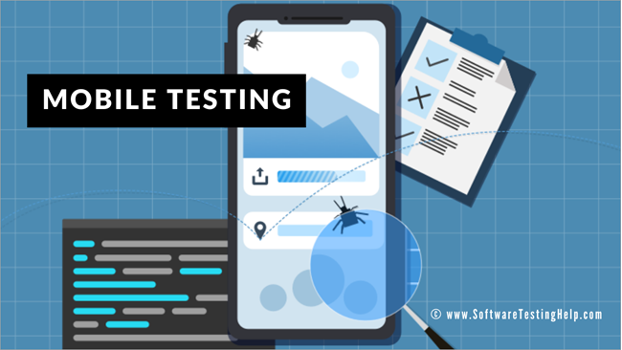](https://cdn.softwaretestinghelp.com/wp-content/qa/uploads/2014/04/Mobile-Testing.png)



**What will you learn in this article?**

In continuation with the detailed and quite insightful article [Beginner’s Guide to Mobile Testing](https://www.softwaretestinghelp.com/beginners-guide-to-mobile-application-testing/), we will here understand the various challenges which are faced when performing Mobile Testing and what are the current solutions available in the market to tackle them all.

According to the [Cap Gemini Quality Report (Mobile Testing),](http://www.capgemini.com/resources/world-quality-report-2013-14-mobile-testing-pull-out) 18% of responding companies say that they do not have enough time to test mobile apps, and 65% do not have the right tools. Also, 52% cite a lack of devices as a reason not to do Mobile Testing. These all are real-time challenges faced by the organizations to successfully perform Mobile Testing.

[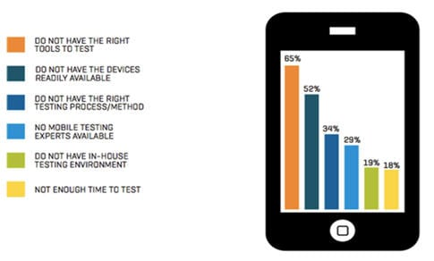](https://cdn.softwaretestinghelp.com/wp-content/qa/uploads/2014/04/mobile-application-challenges-1.jpg)

***Figure 1: Challenges to Mobile Testing***

**What You Will Learn:**[[show](https://www.softwaretestinghelp.com/5-mobile-testing-challenges-and-solutions/)]

**Real-Time Challenges For The Mobile Testing**

**Let us in here, list and understand one by one the real-time challenges for the Mobile Testing:**

#1) Multitude Mobile Devices

Over 500m Android devices shipped since Android 1.0, about 220m iOS devices have been shipped since 2007. These huge number of mobile devices availability ranging from handsets to smartphones, to tabs, to pads and wearable tech provides a huge diversity of environments which your mobile app faces.

Further, the quality team cannot guarantee that if a tested application works well on a given device, it will work 100% on another device even if it’s from the same product family because the screen resolution, CPU, Memory, OS optimization, and hardware could be different.

[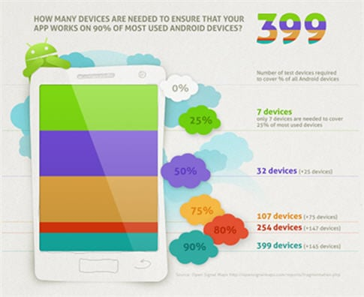](https://cdn.softwaretestinghelp.com/wp-content/qa/uploads/2014/04/mobile-application-challenges-2.jpg)

***Figure 2: Number of Devices for Testing Mobile apps***

**The question to ask in here is, “Whether testing on 5-8 devices is enough? The answer is “Yes” if reaching only 25% of the customer base is “OK” for your CEO.**

#2) Device Fragmentation & Various OS Platforms

Perhaps the most difficult aspect of the mobile testing matrix is device fragmentation. Though the iOS device matrix is growing more than ever, fragmentation is especially an issue for the Android operating system. Take, **For Example,** the image below-

[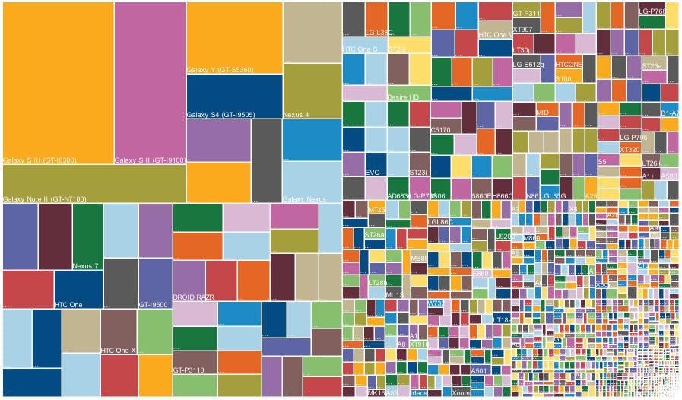](https://cdn.softwaretestinghelp.com/wp-content/qa/uploads/2014/04/mobile-application-challenges-3.jpg)

***Figure 3: Devices and OS platforms***

This is a data chart by [OpenSignal](http://opensignal.com/reports/fragmentation-2013/) of nearly 12,000 separate Android device models encountered in July 2013. (In comparison, the same chart from 2012 found nearly 4,000 devices.) If you’re concerned with quality on cross-platform apps, you’ll encounter a similarly complicated matrix.

Although less daunting than the hardware matrix, the variety of mobile operating systems also poses a challenge for engineering teams whose goal is to provide a consistent user experience across platforms.

Mobile Application Testing is also challenging, due to compatibility issues as a mobile application can be deployed across devices which have different-

1. Operating systems like iOS, Android, Blackberry, Windows, etc.
2. Versions of an operating system such as iOS 4.X, iOS 5.X, BB 4.X, 5.X, and 6.X.

#3) Different Mobile App Types

A mobile app can be a native app, a web app or a hybrid app that has both contents. Testing of each such app type is different than another as their implementation is quite different from one another.

[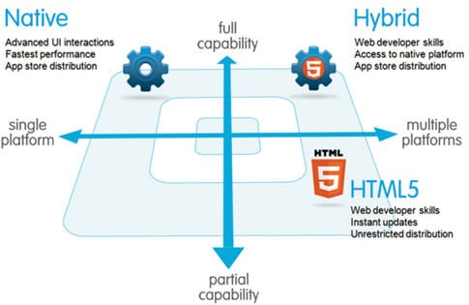](https://cdn.softwaretestinghelp.com/wp-content/qa/uploads/2014/04/mobile-application-challenges-4.jpg)

***Fig 4 – Types of mobile apps***

As we see each app behavior from installation to functionality is different from one another, we understand that their testing and test coverage will also be different. For more details on it, you can refer to the [Beginner’s Guide to Mobile Testing](https://www.softwaretestinghelp.com/beginners-guide-to-mobile-application-testing/)

#4) Numerous Test Interfaces

Mobile emulators and simulators are an important testing tool and they enable us to verify general functionality and perform [regular Regression Testing](https://www.softwaretestinghelp.com/regression-testing-tools-and-methods/). The very character of emulators and simulators means testing is being conducted in an environment that is not real.

The advantages of such tools are limited in scope, and should never be considered a substitute for real-world. Using emulators and simulators in tandem with in-the-wild testing will give you the best results.

[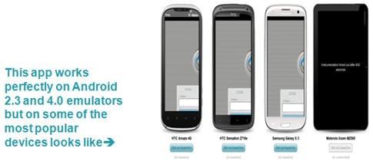](https://cdn.softwaretestinghelp.com/wp-content/qa/uploads/2014/04/mobile-application-challenges-5.jpg)

***Figure 5***

#5) Variety Of Testing Tools

Summarizing the daunting complexity of mobile test automation, even more, daunting is the huge availability of mobile test automation tools in the market. Free/Paid. For a native app or web app? For Android or for iOS, so which is the one automation tool for your mobile test automation needs, or the question is – Is there a single tool for our Mobile Test automation needs?

[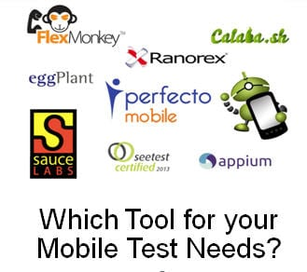](https://cdn.softwaretestinghelp.com/wp-content/qa/uploads/2014/04/mobile-application-challenges-6.jpg)

***Figure 6 – Mobile Test Automation tools***

**Solution**

So what is that ideal solution for your Mobile Testing needs? What are the different measures you ought to take up? Let us have a look at some of them –

**#1) Mobile Test Lab**

If your mobile test needs are immense and often, a good idea is to invest in creating your own mobile test lab.

[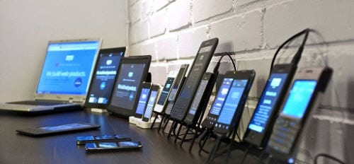](https://cdn.softwaretestinghelp.com/wp-content/qa/uploads/2014/04/mobile-application-challenges-7.jpg)

Or one can as well look for solutions to hire an external test lab or explore the cloud mobile lab solutions. Many companies have already started venturing into it. Some of the websites of these companies are:

**Mobile App Testing Labs in Secure Private Cloud:**

* [MobileLabs](http://mobilelabsinc.com/)
* [Xamarin Test Cloud](http://xamarin.com/test-cloud)
* [SauceLabs](http://saucelabs.com/)

One ought to create a proper sampling of effective mobile device availability which appropriately covers the larger segment of the variety needed. You are required to have this lab to ensure that you have not simply tested your app on an emulator or simulator but on the actual real device.

Also, you have catered well to the variability of OS, device type, fragmentation, screen, memory and other factors that can impact your application functioning on the mobile device.

**#2) The Right Testing Solution**

So what exactly are you looking for in the mobile testing solution? An IDE so that scripting is reduced, a keyword-driven approach so that even manual testers can effectively use it, integration with a mobile cloud to help you overcome device challenges, a tool which helps you identify objects both based on property and on an image as well.

Many solutions are available in the market- Robotium, Appium, Calabash from open source, and in commercial – eggplant, perfecto, etc.

Below given is a comparison table, taken from an [informative blog](https://www.opkey.com/), to help you understand the features available with tools-

[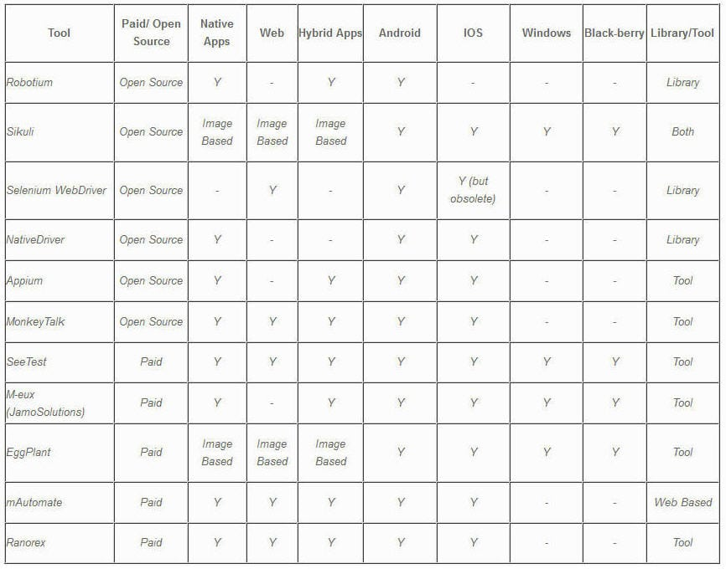](https://cdn.softwaretestinghelp.com/wp-content/qa/uploads/2014/04/mobile-application-challenges-8.jpg)

***Table 1 – Mobile Test Automation solutions comparison***

Conclusion

The above article is an extension to the beginners, where the aim was to specifically highlight the **real-time challenges faced in the world of Mobile Testing**, and present a comparison matrix of these solutions to help the tester make an informed choice about the approach and solution for their mobile test needs.

***About the author:*** This is a guest article by Pallavi Sharma. With overall 9 years of professional experience, she is in the software testing field for the last 7.5 years in the domain of functional, non-functional testing and automation tools like Webdriver, QTP, Sahi, Watir, SoapUI, openSTA, and RPT.

Now she is handling lead and project management roles of varied teams following the SCRUM methodology.

***In our next article, we will discuss more on***[***Why Mobile Testing is Tough?***](https://www.softwaretestinghelp.com/why-mobile-testing-is-tough/)

JIRA Interview Questions And Answers

**Given below is the list of most frequently asked JIRA interview questions and answers.**

**Q #1) Why is JIRA used?**

**Answer:** Atlassian JIRA is basically an issue and project tracking tool which allows us to track any project related work by following a proper workflow.

**Enlisted below are few reasons which determine the usage of JIRA:**

* Able to track project progress from time to time.
* JIRA use-cases include project management, feature implementation, bug tracking, etc.
* Work-flow can be easily customized as per our requirement.
* Along with issue tracking, history of the work done on issues, when, what and by whom can also be tracked.
* JIRA is platform-independent and can run anywhere.

**Q #2) Explain the JIRA workflow.**

**Answer:** Workflow defines the series of steps or stages an issue/ bug goes through during its lifecycle from creation to the closing of the issue.

The workflow here includes the creation of an issue, a series of actions performed to fix the issue and the last step includes the closing or say completion of the issue after verification.

**Refer the below diagram for better understanding:**

[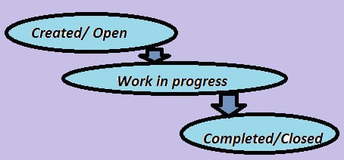](https://cdn.softwaretestinghelp.com/wp-content/qa/uploads/2016/10/JIRA-workflow.jpg)

**Q #3) Enlist the report types generated by JIRA.**

**Answer:** There are multiple reports available in JIRA which are used to show the project statistics throughout the project life cycle. There are general reports available for analyzing issues as well as different reports for Scrum projects and Kanban projects.

**General reports generated as and when required for analyzing issues includes:**

* Average Age Report
* Created vs Resolved issue Report
* Pie Chart Report
* Recently created Issue Report
* Resolution Time Report
* Time Tracking Report
* User Workload Report
* Version Workload Report
* Workload Pie chart Report

**Examples of reports generated for Scrum projects are:**

* Sprint Report
* Control chart
* Burndown chart
* Cumulative Flow diagram
* Epic Report
* Release Burndown
* Velocity chart
* Version Report

**Examples of reports generated for Kanban projects:**

* Control chart
* Cumulative Flow diagram.

**For generating reports for your project, follow the below steps:**

* Navigate to desired project dashboard.
* Click on Reports tab from left-hand side to view different reports.
* Click on Switch report to view the different reports.

[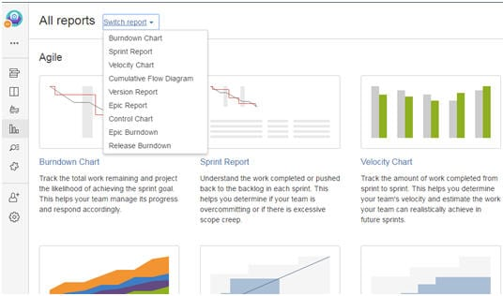](https://cdn.softwaretestinghelp.com/wp-content/qa/uploads/2016/10/Switch-report.jpg)

**Q #4) Explain the step by step procedure of how an issue is created in JIRA.**

**Answer:** Whenever an issue or defect is encountered while testing, it needs to be reported so that the developers can work on it and take the necessary action to fix it.

**We will see step by step as how an issue is created in Atlassian JIRA.**

**a)** Log in to your JIRA account by using valid credentials and get directed to the dashboard.

**b)** Click on ‘Create’ button displayed and you will be navigated to a window for creating an issue.

**c)** Enter all the necessary details as required to create an issue. The below field example can be understood better by the image below.

* In the ***Project***field*, a*project for which we are creating an issue is selected. In this example: STH_Learning(STHL) is selected from the dropdown containing all the available projects.
* In the ***Issue type*** field, the nature of the issue is selected from the dropdown which contains options like Bug, Task, Improvement, Story, New Feature, etc. In this example, ‘Bug’ is the nature of the issue.
* The***Summary*** field contains the one line title of the issue which imparts the critical information about the issue in a summarized way. The more effective the issue headline, the more you can show the criticality of the issue. Of course, the headline should be easily understood without any chances of misinterpretation. The example I have taken here, however, is not much critical.
* The ***Reporter*** is the one who reports the issue. In most of the cases, the name of the Project Manager is selected in this field.
* In ***Description***field, the detailed description of the issue is written. As you can see in the below example screenshot, Steps to reproduce the issue, Actual result, Expected result are included in the description.
* In the ***Affect Version***field***,***the current build version of the project is selected in which the issue has been encountered.
* ***Fix version*** field is basically selected by the concerned developer people, who choose the version as and when their work for the particular issue has been finished and the issue has been fixed.
* ***Priority*** field defines which issue should be considered first to be fixed. Tester selects the priority of the issue from the dropdown based on its effect on the application. This example issue is basically of a Medium priority.
* In the ***Attachment*** field, any video or screenshot related to the issue is being uploaded.
* In***Environment*** field, operating system and browser details are mentioned on which issue has been encountered.

[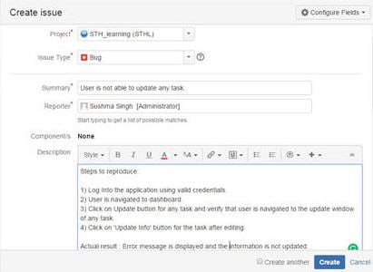](https://cdn.softwaretestinghelp.com/wp-content/qa/uploads/2016/10/Create-issue-1.jpg)

[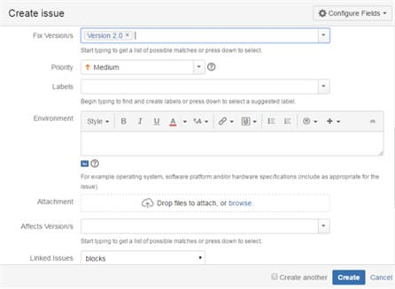](https://cdn.softwaretestinghelp.com/wp-content/qa/uploads/2016/10/Create-issue-2.jpg)

**d)** After all the details have been completed, click on the ‘Create’ button displayed on the window to create the new issue.

**e)** The issue id is generated which can be used in the future as a reference for tracking the progress of the issue.

**Q #5) Explain the three color indicators and their significance.**

**Answer:** For any particular issue in JIRA, 3 colors like Blue, Green, and Orange is used to denote the amount of time spent on any particular issue. This information is displayed under ‘Time Tracking’ section. Each color has its own significance like;

* ***Blue:*** This color is to denote the ‘Original Estimate’ i.e. the time estimate to be invested in resolving the issue. This field has been labeled as ‘Estimated’.
* ***Orange:*** This color determines the time left for resolving the issue. This field has been labeled as ‘Remaining’.
* ***Green:*** This color defines the actual time that has been used or say spent in resolving the issue so far. This field has been labeled as ‘logged’.

[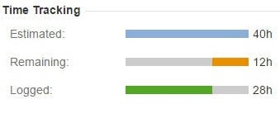](https://cdn.softwaretestinghelp.com/wp-content/qa/uploads/2016/10/Time-Tracking.jpg)

**Q #6) For any particular issue, what all are included under change history?**

**Answer:** Change history section displays the activities of changing any records with information regarding the person who has made the change as well as the time at which the changes have been made.

The change history also displays information about the old and new field values in the case of the change in any field.

**Change history includes the following records of the changes:**

* Creation and deletion of a comment.
* Creation and deletion of an issue link.
* Deletion of a Worklog.
* File attachment changes
* Issue field changes

**Change history for any issue can be viewed in JIRA by following steps:**

* Open any particular issue.
* Click on the ‘History’ tab present in the ‘Activity’ section.

[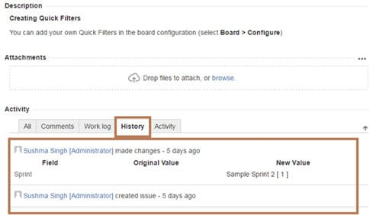](https://cdn.softwaretestinghelp.com/wp-content/qa/uploads/2016/10/history-tab.jpg)

**Q #7) Mention a way with which an issue can be shared with other users in JIRA.**

**Answer:** An issue can be shared with other users in JIRA by using the share option available on the issue description page.

[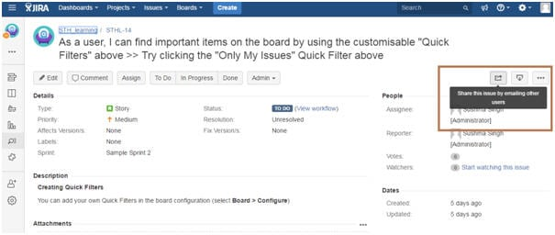](https://cdn.softwaretestinghelp.com/wp-content/qa/uploads/2016/10/share-option.jpg)

When share option for any particular issue is clicked, it contains the link to the issue to be shared along with ‘Username or Email’ and ‘Note’ field that has to be filled.

[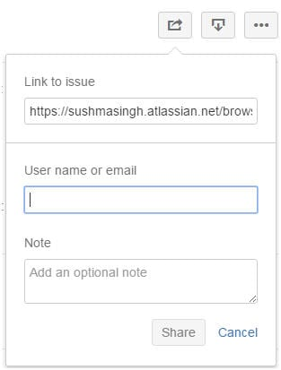](https://cdn.softwaretestinghelp.com/wp-content/qa/uploads/2016/10/share-option-1.jpg)

**Q #8) What is the importance of labeling issue?**

**Answer:** Labeling an issue is basically done to categorize an issue within a particular section which in turn can be easily searched with the help of labels.

Label for a particular issue can be initially set at the time of creating the issue, while it can edit also within the issue. **Label field is displayed under the ‘Details’ section as shown below in the figure:**

[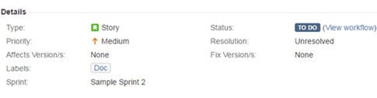](https://cdn.softwaretestinghelp.com/wp-content/qa/uploads/2016/10/labeling-issue.jpg)

**Q #9) How is an issue linked in JIRA?**

**Answer:** As the name itself defines, Linking means the association between the two.

**In the same way, in JIRA issue is linked with any other issue in cases like:**

* Relate to another issue
* Duplicate to another issue
* Block another issue.

For displaying the details of the Linked issues, there are two fields available in JIRA: **‘Linked issues’** and **‘Issues’.**

[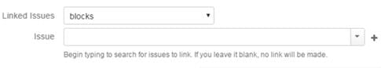](https://cdn.softwaretestinghelp.com/wp-content/qa/uploads/2016/10/Linked-issues.jpg)

Linked issue section contains the dropdown for the options to be selected as the reason for linking the issue. As per the selected option, the suggestion of the issues to be linked in displayed in ‘Issue’ dropdown.

[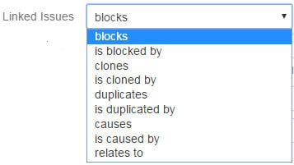](https://cdn.softwaretestinghelp.com/wp-content/qa/uploads/2016/10/Linked-issues-1.jpg)

Linking of issues can be done either on the same or different JIRA servers.

**Q #10) What is the purpose of the JIRA dashboard?**

**Answer:** The first page which is displayed whenever we get logged in to JIRA application is ‘Dashboard’ which is basically the default or system dashboard.

A personal dashboard can also be created and designed by adding different gadgets and can be edited also as and when required. These gadgets are the means to display the project progress in terms of issues, etc.

**Let us understand the steps as how a personal dashboard can be created:**

**a)** Enter valid credentials and get navigated to JIRA dashboard.  
**b)** Click on “…” displayed on the upper right-hand side and choose option ‘Create dashboard’. You can also choose ‘Copy dashboard’ in the case of copying the currently viewed dashboard.

[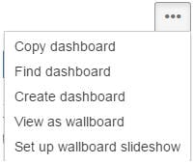](https://cdn.softwaretestinghelp.com/wp-content/qa/uploads/2016/10/Copy-dashboard.jpg)

**c)** ‘Create Dashboard’ page is displayed.  
**d)** Enter all mandatory information and click on ‘Create’ button.

[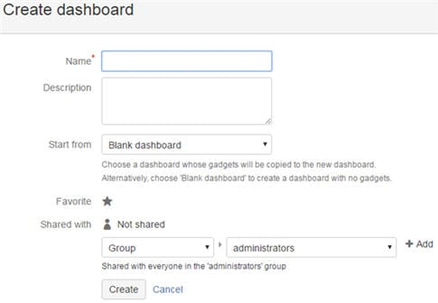](https://cdn.softwaretestinghelp.com/wp-content/qa/uploads/2016/10/Create-dashboard.jpg)

**e)** After creating a dashboard, you get navigated to a page where there are multiple options to select and add gadgets to your dashboard.

[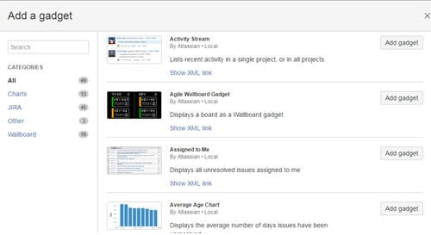](https://cdn.softwaretestinghelp.com/wp-content/qa/uploads/2016/10/add-gadgets.jpg)

**f)** There is also an option available to choose and edit the layout of your dashboard.

Any particular Dashboard can be edited, copied, shared, delete from the Manage Dashboard section.

**Q #11) What do you mean by Scheduling an issue?**

**Answer:** Scheduling the issue means scheduling the work of issue for a particular ‘due date’.

For this function to work, one must have ‘Schedule issue permission’ by JIRA Administrator. In this case, a field with ‘Due Date’ is being populated.

**Q #12) Explain how particular project details are listed in JIRA.**

**Answer:** Every project has some main attributes which have to be displayed in the project summary.

**This attributes include:**

* Name of the project
* Key
* Components
* Versions (if present)

Please refer below screenshot of Project ‘STH_L’ summary page as your reference. Although not much activity has been done in this project but this image will give you a clear idea.

[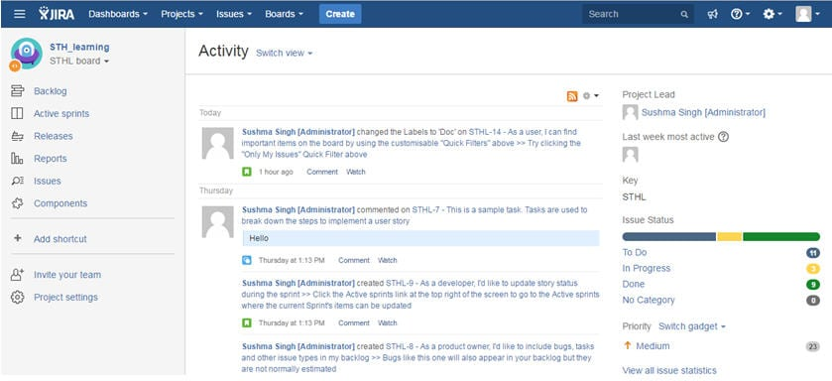](https://cdn.softwaretestinghelp.com/wp-content/qa/uploads/2016/10/Activity.jpg)

As you can see from the image, the middle display area of the page shows the ‘Activity’ screen containing details on the activities done on issues or project.

The right-hand side section displays the basic information about the Project like Project Lead, Key, Issue Status, etc.

The left-hand side contains various options like Components, issues, Reports, Active Sprints, etc. The related information is displayed as per the selection from the option.

**For Example:** If I select the ‘Issue’ option, the below-displayed screen will appear.

[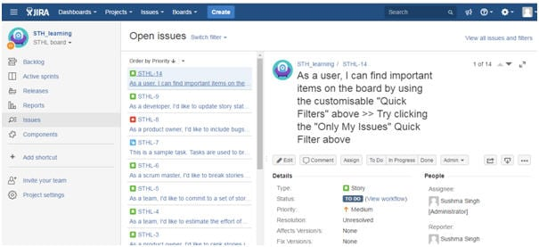](https://cdn.softwaretestinghelp.com/wp-content/qa/uploads/2016/10/Issue-option.jpg)

**Q #13) What are issues types that are created and tracked via JIRA?**

**Answer:** JIRA has some defined set of default issue types which are displayed under ‘Issue Type’ section.

Other issue types can be added, edited and deleted as per requirement of the project. Some of the common issue types are Bug, Task, Sub-task, Epic, Story, etc.

Their details can also be seen under Issue type section as shown in the below figure.

[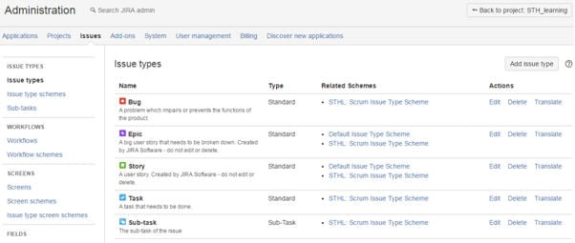](https://cdn.softwaretestinghelp.com/wp-content/qa/uploads/2016/10/Administration.jpg)

As the definition of ‘***Issue Type Schema’*** mentioned in JIRA application,

An issue type scheme determines which issue types will be available to a set of projects. It also allows specifying the order in which the issue types are presented in the user interface.

**There are two types of Issue type Schema:**

* Default Issue type schema
* Scrum Issue type schema

[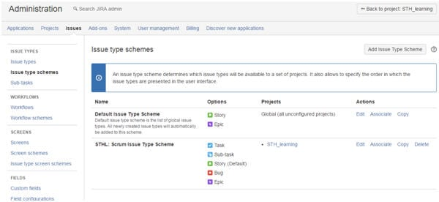](https://cdn.softwaretestinghelp.com/wp-content/qa/uploads/2016/10/Administration-1.jpg)

**Q #14) How is a sub-task created in JIRA?**

**Answer:** Sub-task is the way of splitting up of parent issue into a number of small tasks which are tracked and worked on separately.

The parent issue contains the information of all its sub-tasks which can be only of the same project. A parent issue cannot be closed unless and until all its sub-tasks are closed. A sub-task has the same fields as that of any standard-issue but their issue types are different.

Now,**let us see step by step how a sub-task is created. I have created an issue in the below example for the understanding creation of the sub-task.**

**a)** Open a parent issue by searching with an issue id or create any new issue id.  
**b)** On the right-hand side of the issue description screen, you will see “…”. Click on it and options are displayed.  
**c)** Click on Create Sub-task from the displayed dropdown option.

[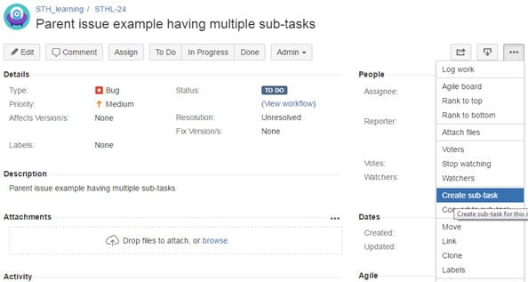](https://cdn.softwaretestinghelp.com/wp-content/qa/uploads/2016/10/Create-Sub-task.jpg)

**d)** Create a sub-task window is displayed.  
**e)** Enter all the mandatory details and click on the ‘Create’ button.

[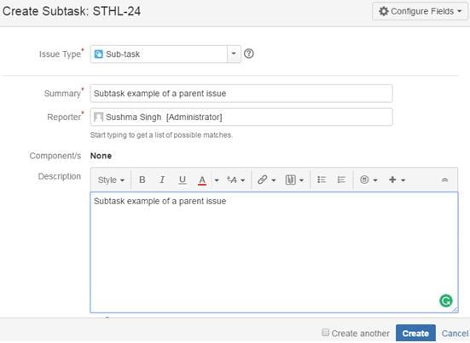](https://cdn.softwaretestinghelp.com/wp-content/qa/uploads/2016/10/Create-button.jpg)

**f)** Now the created sub-task gets added to the parent issue under sub-task section as shown below in the figure:

[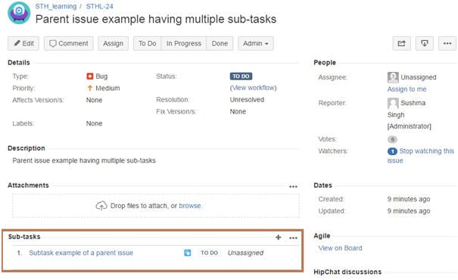](https://cdn.softwaretestinghelp.com/wp-content/qa/uploads/2016/10/sub-task-section.jpg)

**g)** There are also options available to convert an issue into a sub-task as well as sub-task into an issue.

**Q #15) Explain the term Cloning an issue.**

**Answer:** Cloning an issue means copying an issue.

In this condition, a clone of the original issue is created which consist of same information as is present for the original issue. Cloning of the issue is done so that multiple users can work on the same issue, however, the operation done either on the original issue or clone issue has no effect on each other.

**All the information of the original issue are cloned expect few as mentioned below:**

* Time tracking
* Comments’
* Issue history
* Status and Resolution

**Let us see how to create a clone of an issue:**

**a)** Open any issue by searching with an issue id or create any new issue id.  
**b)** On the right-hand side of the issue description screen, you will see “…”. Click on it and options are displayed.  
**c)** Click on Clone from the displayed dropdown option.

[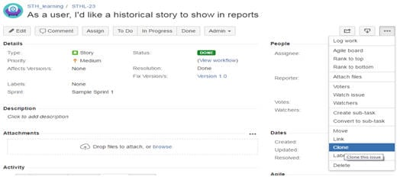](https://cdn.softwaretestinghelp.com/wp-content/qa/uploads/2016/10/Clone.jpg)

**d)** Clone Issue window is displayed.  
**e)** If required, you can edit the summary of the issue and click on the ‘Create’ button.

[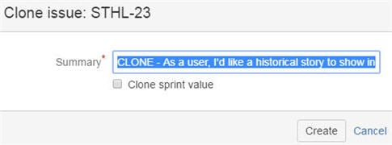](https://cdn.softwaretestinghelp.com/wp-content/qa/uploads/2016/10/Create-button-2.jpg)

**f)** Another issue is created with ‘CLONE’ added in the summary.

**Q #16) Explain the Kanban board.**

**Answer:** Kanban boards are created for the projects where the team has their prime focus on visualizing the workflow and managing the project’s work in progress.

The most important feature of Kanban board is that it is found in work mode because the projects do not have their work as planned.

**Let us see how the Kanban board is created in JIRA step by step.**

**a)** Log In to the JIRA application using valid credentials and get navigated to the dashboard.  
**b)** Click on Project dropdown and select the option ‘Create Project’.  
**c)** Select ‘Kanban Software development’ and click on the Next button.

[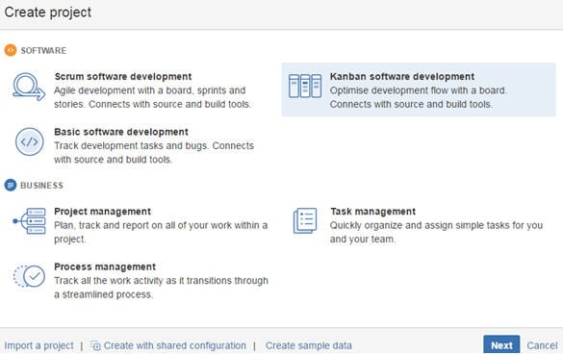](https://cdn.softwaretestinghelp.com/wp-content/qa/uploads/2016/10/Kanban-Software-development.jpg)

**d)** Enter all the necessary details and click on the Create button.  
**e)** Kanban board is created as shown in the below example.

**Note:** I have just taken a basic example of creation

[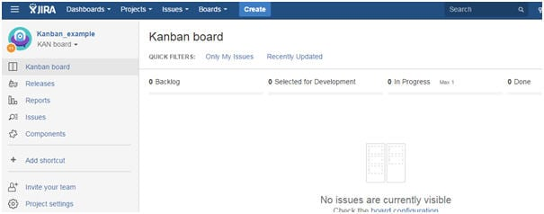](https://cdn.softwaretestinghelp.com/wp-content/qa/uploads/2016/10/example-of-creation.jpg)

In the case of Kanban, the incoming task is given more priority and hence it is considered as the best methodology for cases like bug fixing and maintenance release.

**Q #17) Mention one similarity and one difference between JIRA Scrum and JIRA Kanban.**

**Answer:**

***Similarity:*** Both JIRA Scrum and Kanban is considered as the most powerful process tool for optimization of work and the processes as both processes focus is on continuous optimization and visualizing the workflow. In these cases, large and the complex tasks are broken down and each individual tasks are worked on and completed efficiently.

***Difference:***Scrum board is the work mode where progress of sprints and tracking of its work is done. Here the team determines the list of issues that has become backlog and then these issues are moved to sprints as per team plan.

In the case of the Kanban board, the work in progress activities is being maintained and their process flow is tracked. Here the team decides the increase and decrease of the number of issues that is to be displayed in each status of the workflow.

**Q #18) What are the most useful JIRA add-ons.**

**Answer:** **Some of the most useful JIRA add-ons are listed below:**

* Jenkins-CI
* Usersnap
* Slack
* HipChat
* GitHub
* PagerDuty
* Tempo Timesheets

**Q #19) What comes under JIRA Schema?**

**Answer:** **JIRA Schema consists of the following:**

* Workflows
* Issue types
* Custom fields
* Screens
* Field configurations
* Notifications
* Permissions

**Q #20) How is the security setting helpful in JIRA?**

**Answer:** The security setting for any issue is defined or say set either at the time of the creation of the issue or while editing the issue.

The basic reason for security settings is to restrict user access to the issue so that not all users are able to work on that issue. Security setting also allows the access of the issue to the member of chosen security level.

Conclusion

Through this article, I have covered everything which is necessary to know as a part of understanding and learning this famous and most useful issue tracking tool i.e. JIRA.

Although it was not possible to take any ongoing project as an example to make things clear, I have created a new id and new project in JIRA, so that I can provide my answers with screenshots for better understanding. Hope this article proves helpful for your preparation for interviews.

***All the best and keep learning.***

**=>**[**Visit Here For Complete JIRA Tutorials Series**](https://www.softwaretestinghelp.com/atlassian-jira-tutorial-1/)

***We hope these extensive tutorials on JIRA would have immensely enriched your knowledge on JIRA to a great extent!!***

[**PREV Tutorial**](https://www.softwaretestinghelp.com/jira-alternatives/) **|**[**NEXT Tutorial**](https://www.softwaretestinghelp.com/jira-time-tracking/)

Recommended Reading

* [11 Best JIRA Alternatives in 2020 (Research Done for You)](https://www.softwaretestinghelp.com/jira-alternatives/)
* [GitLab Jira Integration Tutorial](https://www.softwaretestinghelp.com/gitlab-jira-integration/)
* [Guide to JIRA Workflow: Managing Issue Workflow and JIRA Reports](https://www.softwaretestinghelp.com/atlassian-jira-tutorial-4/)
* [How to Integrate JIRA with qTest: A Step by Step Guide](https://www.softwaretestinghelp.com/how-to-integrate-jira-with-qtest/)
* [Integrate JIRA With TestLodge Test Case Management System: Step-by-Step Tutorial](https://www.softwaretestinghelp.com/integrate-jira-with-testlodge/)
* [JIRA Administration Tutorial: JIRA Admin and User Management](https://www.softwaretestinghelp.com/atlassian-jira-tutorial-5/)
* [JIRA Agile Tutorial: How to Use JIRA Effectively for Managing Agile Projects](https://www.softwaretestinghelp.com/atlassian-jira-tutorial-6/)
* [JIRA and SVN Integration Tutorial](https://www.softwaretestinghelp.com/jira-svn-integration/)
* [JIRA Bug Tracking Tool Tutorial: How to Use JIRA as a Ticketing Tool](https://www.softwaretestinghelp.com/jira-bug-tracking/)
* [JIRA Dashboard Tutorial: How to Create JIRA Dashboard with Example](https://www.softwaretestinghelp.com/jira-dashboard/)
* [Jira Download and Installation with Jira License Setup](https://www.softwaretestinghelp.com/jira-download-installation/)
* [Jira Portfolio Tutorial: Agile Project Portfolio Management Plug-in for JIRA (Review)](https://www.softwaretestinghelp.com/portfolio-for-jira/)
* [JIRA Scrum Board Tutorial: Scrum Handling with Jira For Managing the Sprint](https://www.softwaretestinghelp.com/jira-scrum-board-sprint/)
* [JIRA Sub-Task with Example (JIRA Create Sub-task)](https://www.softwaretestinghelp.com/atlassian-jira-tutorial-3/)
* [Jira Time Tracking: How To Use Jira Time Management Software?](https://www.softwaretestinghelp.com/jira-time-tracking/)
* [JIRA Tutorial: A Complete Hands-on How-To-Use JIRA Guide](https://www.softwaretestinghelp.com/atlassian-jira-tutorial-1/)
* [Press Release: Test Management Add-on, Zephyr for JIRA, is now Available in the Cloud](https://www.softwaretestinghelp.com/press-releases/zephyr-for-jira-in-cloud/)
* [Test Automation for Jira with Katalon Studio](https://www.softwaretestinghelp.com/jira-integration-with-katalon-studio/)
* [TestRail Test Management for Jira - A Comprehensive Guide](https://www.softwaretestinghelp.com/testrail-test-management-for-jira/)
* [Top 20 Most Important JIRA Interview Questions and Answers](https://www.softwaretestinghelp.com/interview-questions/top-20-most-important-jira-interview-questions-and-answers/)

About SoftwareTestingHelp

**Helping our community since 2006!** Most popular portal for Software professionals with **100 million+ visits!** You will absolutely love our tutorials on Software Testing, Development, Software Reviews and much more!

**Join Over 200,000+ Testers**

**Get premium ebooks and testing tips.**

SUBSCRIBE NOW!

Join Over 300,000+ Followers!

Top FREE Training Tutorials

* [Load Testing Buyer’s Guide](https://bit.ly/2GIM0bM)
* [Free QA Training](https://www.softwaretestinghelp.com/free-online-software-testing-qa-training-course/)
* [Selenium Tutorials](https://www.softwaretestinghelp.com/selenium-tutorial-1/)
* [QTP/UFT Tutorials](https://www.softwaretestinghelp.com/qtp-quicktest-professional-tutorial-1/)
* [Quality Center QC Tutorials](https://www.softwaretestinghelp.com/learn-hp-quality-center-qc-in-4-days/)
* [LoadRunner Tutorials](https://www.softwaretestinghelp.com/hp-loadrunner-load-testing-tool-training-tutorials/)
* [JMeter Tutorials](https://www.softwaretestinghelp.com/jmeter-tutorials/)
* [JIRA Tutorials](https://www.softwaretestinghelp.com/atlassian-jira-tutorial-1/)
* [VBScript Tutorials](https://www.softwaretestinghelp.com/vbscript-tutorial-1/)
* [Best Test Management Tools](https://www.softwaretestinghelp.com/15-best-test-management-tools-for-software-testers/)
* [Unix Tutorials](https://www.softwaretestinghelp.com/unix-tutorials/)
* [DevOps Tutorials](https://www.softwaretestinghelp.com/devops-tutorials/)
* [JAVA Tutorials](https://www.softwaretestinghelp.com/java/)
* [Python Tutorials](https://www.softwaretestinghelp.com/python/)
* [Free C++ Tutorials](https://www.softwaretestinghelp.com/cpp-tutorials/)
* [101+ Interview Questions](https://www.softwaretestinghelp.com/software-testing-interview-questions/)

Join Our Team!

[](https://www.softwaretestinghelp.com/sth-current-job-openings/)

[**ABOUT US**](https://www.softwaretestinghelp.com/about/)**|**[**CONTACT US**](https://www.softwaretestinghelp.com/contact/)**|**[**ADVERTISE**](https://www.softwaretestinghelp.com/advertise-on-software-testing-help/)**|**[**TESTING SERVICES**](https://www.softwaretestinghelp.com/best-qa-software-testing-service-provider-company/)ALL ARTICLES ARE COPYRIGHTED AND CAN NOT BE REPRODUCED WITHOUT PERMISSION.  
© COPYRIGHT SOFTWARETESTINGHELP 2020 — READ OUR [**COPYRIGHT POLICY**](https://www.softwaretestinghelp.com/copyright-policy/)**|**[**PRIVACY POLICY**](https://www.softwaretestinghelp.com/privacy/)**|**[**TERMS**](https://www.softwaretestinghelp.com/terms-of-use/)**|**[**COOKIE POLICY**](https://www.softwaretestinghelp.com/cookie-policy/)**|**[**AFFILIATE DISCLAIMER**](https://www.softwaretestinghelp.com/affiliate-disclaimer/)**|**[**LINK TO US**](https://www.softwaretestinghelp.com/link-to-us/)

[Software Testing Help](https://www.softwaretestinghelp.com/sth-current-job-openings/)

[Scroll](https://www.softwaretestinghelp.com/interview-questions/top-20-most-important-jira-interview-questions-and-answers/)

* [Prev](https://www.wisdomjobs.com/e-university)

* [Next](https://www.wisdomjobs.com/e-university/manual-testing-practice-tests-300-327455)

Manual Testing Interview Questions

* [[](https://www.wisdomjobs.com/e-university/testing-tools-tutorial-239.html) Testing Tools Tutorial](https://www.wisdomjobs.com/e-university/testing-tools-tutorial-239.html)

* [[](https://www.wisdomjobs.com/e-university/manual-testing-practice-tests-300-327455) Manual Testing Practice Test](https://www.wisdomjobs.com/e-university/manual-testing-practice-tests-300-327455)
* [[](javascript:void(0);) Manual Testing Pragnya Meter Exam](javascript:void(0);)

* [[](https://www.wisdomjobs.com/manual-testing-jobs) Manual Testing Jobs](https://www.wisdomjobs.com/manual-testing-jobs)

* [[](https://www.wisdomjobs.com/e-university/all-skillsets-interview-questions.html) All Interview Questions](https://www.wisdomjobs.com/e-university/all-skillsets-interview-questions.html)
  1. **Question 1. What Is Baseline Testing?**

**Answer :**

Baseline testing is the process of running a set of tests to capture performance information. Baseline testing use the information collected to made the changes in the application to improve performance and capabilities of the application. Baseline compares present performance of application with its own previous performance.

* 1. **Question 2. What Is Benchmark Testing?**

**Answer :**

Benchmarking testing is the process of comparing application performance with respect to industry standard which is given by some other organization. Benchmark informs us where our application stands with respect to others. Benchmark compares our application performance with other company’s application’s performance.

[Testing Tools Interview Questions](https://www.wisdomjobs.com/e-university/testing-tools-interview-questions.html)

* 1. **Question 3. What Is Verification And Validation?**

**Answer :**

Verification: process of evaluating work-products of a development phase to determine whether they meet the specified requirements for that phase.

Validation: process of evaluating software during or at the end of the development process to determine whether it specified requirements.

Difference between Verification and Validation:  
•Verification is Static Testing where as Validations is Dynamic Testing.  
•Verification takes place before validation.  
•Verification evaluates plans, document, requirements and specification, where as Validation evaluates product.  
•Verification inputs are checklist, issues list, walkthroughs and inspection ,where as in Validation testing of actual product.  
•Verification output is set of document, plans, specification and requirement documents where as in Validation actual product is output.

* 1. **Question 4. Explain Branch Coverage And Decision Coverage.**

**Answer :**

•Branch Coverage is testing performed in order to ensure that every branch of the software is executed atleast. To perform the Branch coverage testing we take the help of the Control Flow Graph.   
•Decision coverage testing ensures that every decision taking statement is executed atleast once.  
•Both decision and branch coverage testing is done to ensure the tester that no branch and decision taking statement, will not lead to failure of the software.  
•To Calculate Branch Coverage:

Branch Coverage = Tested Decision Outcomes / Total Decision Outcomes.

[Testing Tools Tutorial](https://www.wisdomjobs.com/e-university/testing-tools-tutorial-239.html)

* 1. **Question 5. What Is Difference Between Retesting And Regression Testing?**

**Answer :**

•Retesting is done to verify defect fix previous in now working correctly where as regression is perform to check if the defect fix have not impacted other functionality that was working fine before doing changes in the code.  
•Retesting is specific and is performed on the bug which is fixed where as in regression is not be always specific to any defect fix it is performed when any bug is fixed.  
•Retesting concern with executing those test cases that are failed earlier where as regression concern with executing test cases that was passed in earlier builds.  
•Retesting has higher priority over regression.

[QTP Interview Questions](https://www.wisdomjobs.com/e-university/qtp-interview-questions.html)

* 1. **Question 6. What Is Mutation Testing & When Can It Be Done?**

**Answer :**

Mutation testing is a performed to find out the defect in the program. It is performed to find put bugs in specific module or component of the application. Mutation testing is based on two assumptions:

Competent programmer hypothesis: according this hypothesis we suppose that program write the correct code of the program.

Coupling effect: according to this effect collection of different set of test data can also find large and complex bugs.

* 1. **Question 7. Explain Bug Leakage And Bug Release.**

**Answer :**

**Bug Leakage:** When customer or end user discovered a bug which can be detected by the testing team. Or when a bug is detected which can be detected in pervious build then this is called as Bug Leakage.

Bug release: is when a build is handed to testing team with knowing that defect is present in the release. The priority and severity of bug is low. It is done when customer want the application on the time. Customer can tolerate the bug in the released then the delay in getting the application and the cost involved in removing that bug. These bugs are mentioned in the Release Notes handed to client for the future improvement chances.

[QTP Tutorial](https://www.wisdomjobs.com/e-university/qtp-tutorial-260.html) [Database Testing Interview Questions](https://www.wisdomjobs.com/e-university/database-testing-interview-questions.html)

* 1. **Question 8. What Is Alpha And Beta Testing?**

**Answer :**

Alpha testing: is performed by the IN-House developers. After alpha testing the software is handed over to software QA team, for additional testing in an environment that is similar to the client environment.

Beta testing: beta testing becomes active. It is performed by end user. So that they can make sure that the product is bug free or working as per the requirement. IN-house developers and software QA team perform alpha testing. The public, a few select prospective customers or the general public performs beta testing.

* 1. **Question 9. What Is Monkey Testing?**

**Answer :**

Monkey testing is a type of Black Box Testing used mostly at the Unit Level. In this tester enter the data in any format and check the software is not crashing. In this testing we use Smart monkey and Dumb monkey.

Smart monkeys are used for load and stress testing, they will help in finding the bugs. They are very expensive to develop. Dumb monkey, are important for basic testing. They help in finding those bugs which are having high severity. Dumb monkey are less expensive as compare to Smart monkeys.

Example: In phone number filed Symbols are entered.

[Automation Testing Interview Questions](https://www.wisdomjobs.com/e-university/automation-testing-interview-questions.html)

* 1. **Question 10. What Is Test Driver And Test Stub?**

**Answer :**

•The Stub is called from the software component to be tested. It is used in top down approach.  
•The driver calls a component to be tested. It is used in bottom up approach.  
•Both test stub and test driver are dummy software components.

We need test stub and test driver because of following reason:  
•Suppose we want to test the interface between modules A and B and we have developed only module A. So we cannot test module A but if a dummy module is prepare, using that we can test module A.  
•Now module B cannot send or receive data from module A directly so, in these cases we have to transfer data from one module to another module by some external features. This external feature used is called Driver.

[Database Testing Tutorial](https://www.wisdomjobs.com/e-university/database-testing-tutorial-966.html)

* 1. **Question 11. What Is Random Testing?**

**Answer :**

When tester performs testing of application by using random input from the input domain of the system, this is Random Testing.

Random testing involve following procedures:  
•Selection of input domain.  
•Randomly selecting any input from input domain.  
•Using these test input testing of application is performed.  
•The results are compared to the system specification. The test is a failure if any input leads to incorrect results, otherwise it is a success.

[Software testing Interview Questions](https://www.wisdomjobs.com/e-university/software-testing-interview-questions.html)

* 1. **Question 12. What Is Agile Testing?**

**Answer :**

Agile Testing means to quickly validation of the client requirements and make the application of good quality user interface. When the build is released to the testing team, testing of the application is started to find the bugs. As a Tester, we need to focus on the customer or end user requirements. We put the efforts to deliver the quality product in spite of short time frame which will further help in reducing the cost of development and test feedbacks will be implemented in the code which will avoid the defects coming from the end user.

[Testing Tools Interview Questions](https://www.wisdomjobs.com/e-university/testing-tools-practice-tests-239-327206)

* 1. **Question 13. What Is The Purpose Of Test Strategy?**

**Answer :**

We need Test Strategy for the following reasons:  
1. To have a signed, sealed, and delivered document, where the document contains details about the testing methodology, test plan, and test cases.  
2. Test strategy document tells us how the software product will be tested.  
3. Test strategy document helps to review the test plan with the project team members.  
4. It describes the roles, responsibilities and the resources required for the test and schedule.  
5. When we create a test strategy document, we have to put into writing any testing issues requiring resolution.

The test strategy is decided first, before lower level decisions are made on the test plan, test design, and other testing issues.

[Software testing Tutorial](https://www.wisdomjobs.com/e-university/software-testing-tutorial-1303.html)

* 1. **Question 14. Explain Bug Life Cycle.**

**Answer :**

•The bug is assigned to development project manager who will analyze the bug .He will check whether it is a valid defect. If not valid bug is rejected then status is REJECTED.  
•If not, next the defect is checked whether it is in scope. When bug is not part of the current release .Such defects are POSTPONED  
•Now, Tester checks whether a similar defect was raised earlier. If yes defect is assigned a status DUPLICATE  
•When bug is assigned to developer. During this stage bug is assigned a status IN-PROGRESS  
•Once code is fixed. Defect is assigned a status FIXED  
•Next the tester will re-test the code. In case the test case passes the defect is CLOSED  
•If the test case fails again the bug is RE-OPENED and assigned to the developer. That’s all to Bug Life Cycle.

* 1. **Question 15. What Is Error Guessing And Error Seeding?**

**Answer :**

Error Guessing is a test case design technique where the tester has to guess what faults might occur and to design the tests to represent them.

Error Seeding is the process of adding known faults intentionally in a program for the reason of monitoring the rate of detection & removal and also to estimate the number of faults remaining in the program.

[Test Cases Interview Questions](https://www.wisdomjobs.com/e-university/test-cases-interview-questions.html)

* 1. **Question 16. Explain Compatibility Testing With An Example.**

**Answer :**

Compatibility testing is to evaluate the application compatibility with the computing environment like Operating System, Database, Browser compatibility, backwards compatibility, computing capacity of the Hardware Platform and compatibility of the Peripherals. Example, If Compatibility testing is done on a Game application, before installing a game on a computer, its compatibility is checked with the computer specification that whether it is compatible with the computer having that much of specification or not.

* 1. **Question 17. What Is Test Harness?**

**Answer :**

A test harness is a collection of software and test data required to test the application by running it in different testing condition like stress, load, data- driven, and monitoring its behavior and outputs. Test Harness contains two main parts:  
•Test execution engine  
•Test script repository

Automation testing is the use of a tool to control the execution of tests and compare the actual results with the expected results. It also involves the setting up of test pre-conditions.

[Web testing Interview Questions](https://www.wisdomjobs.com/e-university/web-testing-interview-questions.html)

* 1. **Question 18. Explain Statement Coverage.**

**Answer :**

Statement Coverage is a metric used in White Box Testing. Statement coverage is used to ensure that all the statement in the program code is executed at least once. The advantages of Statement Coverage are:  
•Verifies that written code is correct.  
•Measures the quality of code written.  
•Determine the control flow of the program.  
•To Calculate Statement Coverage:  
•Statement Coverage = Statements Tested / Total No. of Statements.

[QTP Interview Questions](https://www.wisdomjobs.com/e-university/qtp-interview-questions.html)

* 1. **Question 19. What Are The Types Of Testing?**

**Answer :**

There are two types of testing:  
•Static testing: Static testing is a technique used in the earlier phase of the development life cycle. The code error detection and execution of program is not concern in this type of testing. Also known as non-execution technique. The Verification of the product is performed in this testing technique like Code Reviews, Inspections, Walkthroughs are mostly done in this stage of testing.  
•Dynamic testing: Dynamic Testing is concern with the execution of the software. This technique is used to test the dynamic behavior of the code. Most of the bugs are identified using this technique. These are the Validation activities. It uses different methodologies to perform testing like Unit Tests, Integration Tests, System Tests and Acceptance Testing, etc.

* 1. **Question 20. Explain User Acceptance Testing.**

**Answer :**

User Acceptance Testing (UAT) is performed by the end users on the applications before accepting the application.

Alpha testing: is performed by the IN-House developers. After alpha testing the software is handed for the Beta testing phase, for additional testing in an environment that is similar to the client environment.

Beta testing: is performed by the end user. So that they can make sure that the product is bug free or working as per the requirement. IN-house developers and software QA team perform alpha testing. The public, a few select prospective customers or the general public performs beta testing.

Gamma Testing: Gamma Testing is done when the software is ready for release with specified requirements. This testing is done directly by skipping all the in-house testing activities.

[Rational Functional Tester Interview Questions](https://www.wisdomjobs.com/e-university/rational-functional-tester-interview-questions.html)

* 1. **Question 21. What Should Be Done After A Bug Is Found?**

**Answer :**

After finding the bug the first step is bug to be locked in bug report. Then this bug needs to be communicated and assigned to developers that can fix it. After the bug is fixes by the developer, fixes should be re-tested, and determinations made regarding requirements for regression testing to check that fixes didn't create problems elsewhere.

* 1. **Question 22. What If The Software Is So Buggy It Can't Really Be Tested At All?**

**Answer :**

In this situation is for the testers to go through the process of reporting of bugs with the focus being on critical bugs. Since this type of problem can severely affect schedules, and indicates deeper problems in the software development process project managers should be notified, and provided with some documentation.

* 1. **Question 23. What Are The Types Of Maintenance?**

**Answer :**

There are four types of maintenance. They are:  
•Corrective Maintenance  
•Adaptive Maintenance  
•Perfective Maintenance  
•Preventive Maintenance

[Test Estimation Interview Questions](https://www.wisdomjobs.com/e-university/test-estimation-interview-questions.html)

* 1. **Question 24. What Are The Advantages Of Waterfall Model?**

**Answer :**

The advantages of the waterfall model are:  
•Simple to implement and required fewer amounts of resources.  
•After every phase output is generate.  
•Help in methods of analysis, design, coding, testing and maintenance.  
•Preferred in projects where quality is more important than schedule and cost.  
•Systematic and sequential model.  
•Proper documentation of the project.

[Database Testing Interview Questions](https://www.wisdomjobs.com/e-university/database-testing-interview-questions.html)

* 1. **Question 25. What Is Rapid Application Development Model (rad)?**

**Answer :**

The RAD model Rapid Application development (RAD) is incremental software development process models that focus on the development of the project in very short time. It is enhanced version of Waterfall model. It is proposed when requirements and solutions can be made independently system or software components, which is developed by different teams. After these smaller system components are developed, they are integrated to produce the large software system solution.

* 1. **Question 26. What Are The Advantages Of Black Box Testing?**

**Answer :**

The advantages of this type of testing include:  
•Developer and tester are independent of each other.  
•The tester does not need knowledge of any programming languages.  
•The test is done from the point-of-view of the user.  
•Test cases can be designed when specifications are complete.  
•Testing helps to identify issues related to functional specifications.

[Mobile Application Testing Interview Questions](https://www.wisdomjobs.com/e-university/mobile-application-testing-interview-questions.html)

* 1. **Question 27. What Is Software Review?**

**Answer :**

A software review can be defined as a filter for the software engineering process. The purpose of any review is to discover errors in the analysis, design, and coding, testing and implementation phases of the software development cycle. The other purpose of a review is to see whether procedures are applied uniformly and in a manageable manner. It is used to check the process followed to develop the software is right.

[Automation Testing Interview Questions](https://www.wisdomjobs.com/e-university/automation-testing-interview-questions.html)

* 1. **Question 28. What Is Reverse Engineering?**

**Answer :**

By analyzing a final product the process of recreating a design is known as reverse engineering. Reverse engineering is the process followed in order to find difficult, unknown, and hidden information about a software system. It is important when software products lack proper documentation, and are highly unstructured, or their structure has degraded through a series of maintenance efforts. Maintenance activities cannot be performed without a complete understanding of the software system.

* 1. **Question 29. What Is Data Flow Diagram?**

**Answer :**

The Data Flow Diagram gives us information of the flow of data within the application.  
•The DFD can be used to analyze the design of the application.  
•It is a graphical representation of the structure of the data.  
•A developer draws context level DFD first showing interaction between the different components of the application.  
•DFD help in developing the software by clarifying the requirements and major functionalities.  
•DFDs show the flow of data through a system.  
•It is an important modeling tool that allows us to picture a system as a network of functional processes.

[Test Manager Interview Questions](https://www.wisdomjobs.com/e-university/test-manager-interview-questions.html)

* 1. **Question 30. What Is Exploratory Testing?**

**Answer :**

Exploratory testing: means testing an application without a test plan and test script. In exploring testing test explore the application on the basis on his knowledge. The tester has no knowledge about the application previously. He explores the application like an end user and try to use it. While using the application his main motive is to find the bugs which are in the application.

* 1. **Question 31. What Is Compatibility Testing?**

**Answer :**

Compatibility testing is a type of testing used to find out the compatibility between the application and platform on which application works, web browsers, hardware, operating systems etc. Good software must be compatible with different hardware, web browser and database.

* 1. **Question 32. What Is Srs And Brs Document?**

**Answer :**

Software Requirements Specification (SRS) is documented form of the requirement of the customer. It consists of all requirement of the customer regarding that software to be developed. The SRS document work as agreement between the company and the customer consisting of all functional and non functional requirements.

Business Requirement Specification (BRS) are the requirements as described by the business people. The business tells “what” they want for the application to do. In simple word BRS contain the functional requirement of the application.

[Test Director Interview Questions](https://www.wisdomjobs.com/e-university/test-director-interview-questions.html)

* 1. **Question 33. Can You Explain V Model In Manual Testing?**

**Answer :**

**V model:** it is enhanced version of waterfall model where each level of the development lifecycle is verified before moving to next level. In this testing starts at the very beginning. By testing we mean verification by means of reviews and inspections, static testing. Each level of the development life - cycle has a corresponding test plan. A test plan is developed to prepare for the testing of the products of that phase. Be developing the test plans, we can also define the expected results for testing of the products for that level as well as defining the entry and exit criteria for each level.

[Software testing Interview Questions](https://www.wisdomjobs.com/e-university/software-testing-interview-questions.html)

* 1. **Question 34. What Is Concurrency Testing?**

**Answer :**

Concurrency Testing is used to know the effects of using the software by different users at the same time. In this type of testing we have multiple users performing the exact same requests at the same time. It helps in identifying and measuring the problems in Response time, levels of locking and deadlocking in the application. For this we use Load runner to create VUGen (Virtual User Generator) is used to add the number of concurrent users and perform operation on the application on the same time.

* 1. **Question 35. What Is An Inspection In Software Testing?**

**Answer :**

An inspection is more formalized than a walkt hrough. Inspection technique involves 3 to 8 team member consisting of a moderator, reader, and a recorder to take notes. The subject of the inspection is typically a document such as a requirements or a test plan, and the purpose is to find problems and see what is missing, most problems will be found during this preparation. The result of the inspection meeting should be a written report. It is one of the most cost effective methods of ensuring quality.

* 1. **Question 36. A Form Has Four Mandatory Fields To Be Entered Before You Submit. How Many Numbers Of Test Cases Are Required To Verify This? And What Are They?**

**Answer :**

Five test cases are required to test:  
1. Enter the data in all the mandatory fields and submit, should not display error message.  
2. Enter data in any two mandatory fields and summit, should issue an error message.  
3. Do not enter in any of the fields should issue an error message.  
4. If the fields accept only number, enter numbers in the fields and submit, should not issue an error message, try to enter only in two fields should issue an error message, and enter alphabets in two fields and number in other two fields it should issue an error message.  
5. If the fields do not accept special characters, then enter the characters and submit it.

[Test Cases Interview Questions](https://www.wisdomjobs.com/e-university/test-cases-interview-questions.html)

* 1. **Question 37. What Is Cyclomatic Complexity?**

**Answer :**

Cyclomatic complexity is used to measure the complexity of the software using the control flow graph of the software. It is a graphical representation, consisting of following:

NODE: statement of the program is taken as node of the graph.

Edges: the flow of command is denoted by edges. Edges are used to connect two node , this show flow of control from one node to other node in the program.

Using this node and edges we calculate the complexity of the program. This determines the minimum number of inputs you need to test always to execute the program.

* 1. **Question 38. What Is The Key Difference Between Preventative And Reactive Approaches To Testing?**

**Answer :**

Preventative tests are designed early; reactive tests are designed after the software has been produced.

* 1. **Question 39. What Is The Purpose Of Exit Criteria?**

**Answer :**

The purpose of exit criteria is to define when a test level is completed.

* 1. **Question 40. When Is Used Decision Table Testing?**

**Answer :**

Decision table testing is used for testing systems for which the specification takes the form of rules or cause-effect combinations. In a decision table the inputs are listed in a column, with the outputs in the same column but below the inputs. The remainder of the table explores combinations of inputs to define the outputs produced.